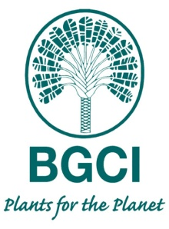

Marsh Award for International Plant Conservation

BGCI is pleased to announce the Marsh Award for International Plant Conservation sponsored by the Marsh Christian Trust. The Marsh Christian Trust was established in 1981 and runs a portfolio of awards which recognise the contribution of dedicated individuals working in different sectors – to improve the world we live in. We aim to give the Marsh Award for International Plant Conservation to an early/mid- career individual who has made an outstanding contribution to the implementation of the Global Strategy for Plant Conservation (GSPC) of the Convention on Biological Diversity (CBD). The prize for this Award in 2015 is £1,000.

Nomination Form

Candidate’s Name:
Job title / freelance role / volunteer status:
Country where undertaking conservation:
Organisation (if relevant):
Address:
Email:
Phone:
Nominated by: Name:
Organization:
Job title:

Signature:

Date:

- Please describe the plant conservation action that your nominee has undertaken and the impact of this work (350 words maximum).

- Please explain, with examples, how your nominee has showed motivation, dedication or innovation beyond their remit in the conservation of threatened plant species (350 words maximum).

- Please state which GSPC Target(s) the nominee has contributed to.

Explanatory Notes

Who can be nominated?
Early/mid-career individuals working to conserve individual plant species and/or the habitats where they occur.

How do you nominate?
Please nominate using the form above. The deadline for nominations is Monday 10 August, 2015. Nominations should be sent to liz.smith@bgci.org with BGCI Marsh Christian Award in the Subject of the email.

How will the award be judged?
Nominations will be judged by a panel comprising two BGCI Board members; and one representative from each of five external organisations, including the Marsh Christian Trust. A final shortlist of three will be sent to Brian Marsh and the Trust for the final selection.

If you have any queries concerning the award in general or how to complete this form in particular then please contact: Paul.smith@bgci.org .

