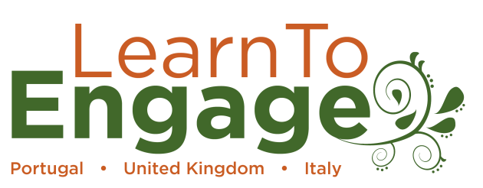
LearnToEnage Multiplier Event
Eurogard VIII
7th – 11th May, 2018
Lisbon, Portugal

Eurogard VIII has been chosen as a venue for a Multiplier Event for LearnToEngage.
What is LearnToEngage?
LearnToEngage is an exciting new suite of professional development modules being developed in partnership between Botanic Gardens Conservation International, Royal Botanic Garden Edinburgh, Nottingham Trent University, National Museum of Natural History and Science, Lisbon and Muse Science Museum, Trento.
The aim of the project is to pilot a blended learning approach to professional development in order to enhance public engagement across Europe and beyond. It will additionally encourage botanic gardens to reach out to new audiences and establish a way of working which caters to the specific needs of their local communities as well as supporting adoption of more rigorous research and evaluation within informal education. The project will result in four modules focussed on different areas of public engagement at botanic gardens.
What is a Multiplier Event?
The Multiplier Event at Eurogard will provide a taster of the Interpretation and Working with Diverse Audiences modules of LearnToEngage. Through a short, hands-on, training session attendees will have the opportunity to learn new skills related to these topics and find out about associated, open access, training resources that can be used to continue this development.
Funding available!
Funding has been made available in order to provide a contribution towards a limited number of participants’ registration fees for Eurogard (100EUR for a participant from Portugal and 200EUR for an international participant). In addition, successful applicants will be eligible for student rates for congress attendance. All individuals receiving this must agree to attend the Multiplier Event.
To be considered for this award please complete the attached application form and return it to Liliana.derewnicka@bgci.org by 12th January, 2018. Applicants will be informed of the status of their application by 19th January

Application form
Name
Organisation
Job title
Email address
Telephone
Address
City
Email
Country
Personal statement (300 words) please include: why you want to be part of this session, how it will benefit your work, how it will benefit your organisation

Details of how and when this will be paid will be provided to successful applicants

