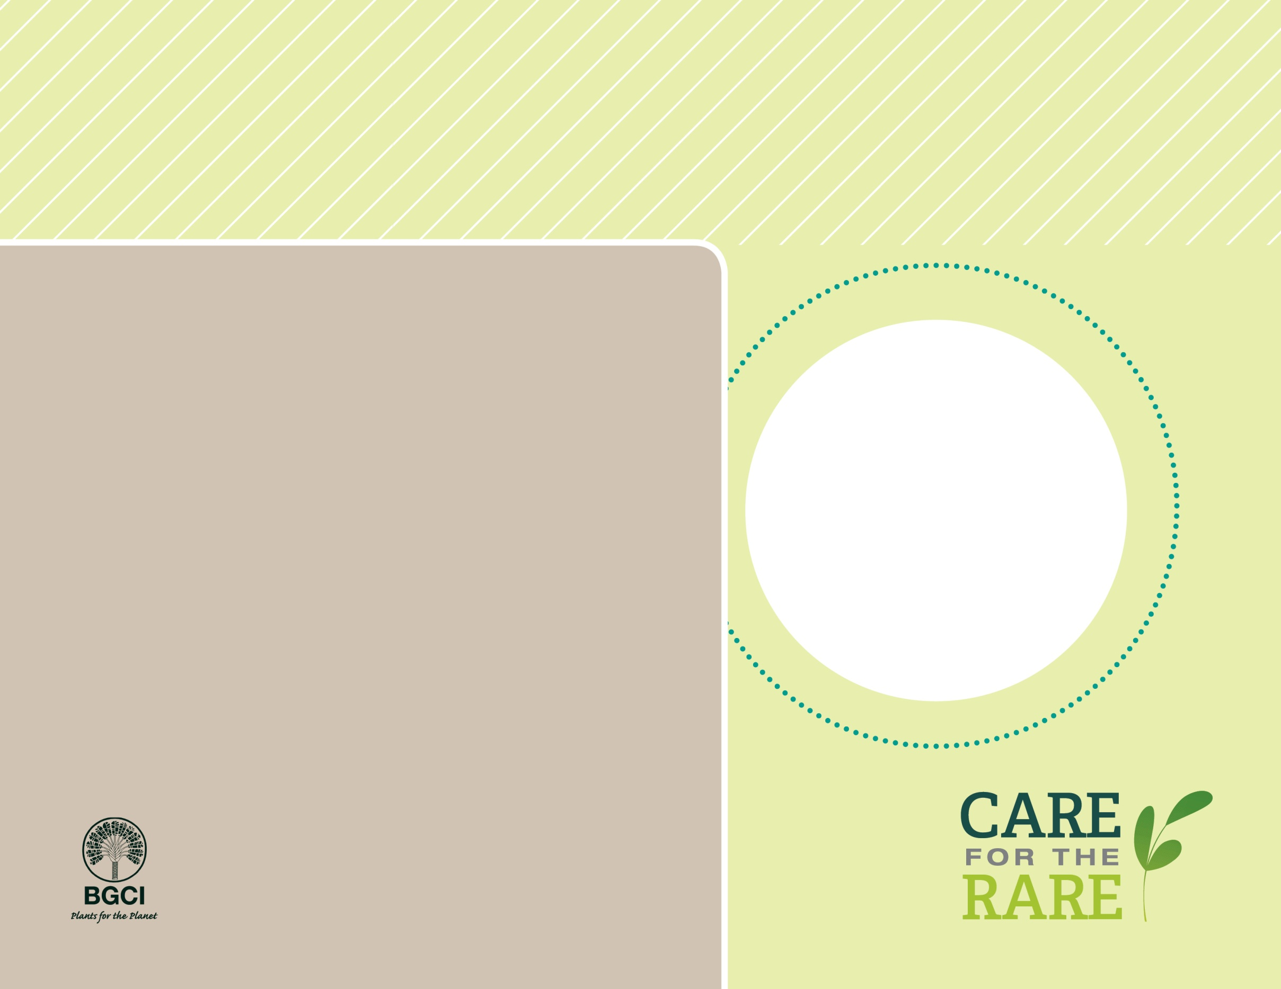

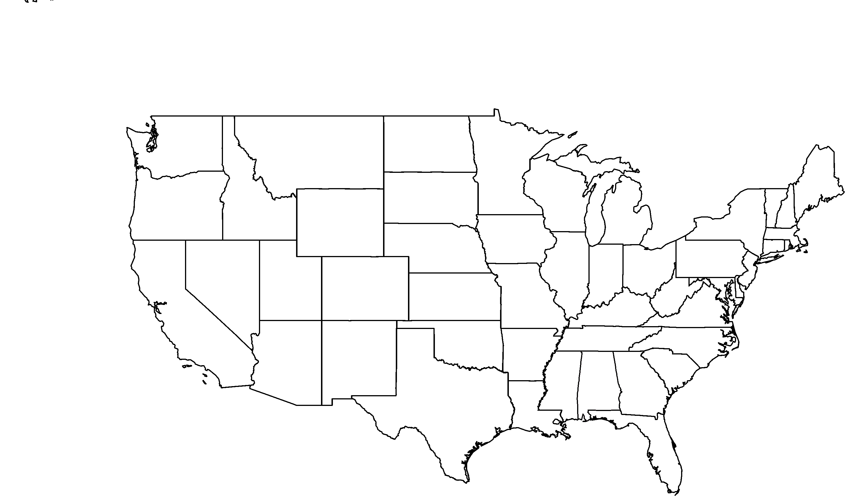

**About me:** My home is the chaparral habitat that is inland from the coastline of San Diego and northwestern Baja California. I have little, white urn-shaped flowers and thin white bark.

**Why I’m rare:** In California, I live on a single mesa along the international border. I am constantly threatened by border patrol activities, habitat conversion, and fire suppression.

**My story:** I am listed as endangered in California. Although that status has not prevented the decline of my habitat, there have been substantial conservation efforts to transplant some of my kind to safety.

**How you can help:** Tread carefully! Protect native plants and plant communities by staying on designated trails when hiking.

**PHOTO BY: RANCHO SANTA ANA BOTANIC GARDEN**

Palo blanco*Ornithostaphylos oppositifolia*

**Your**

**Logo**

**Here**