

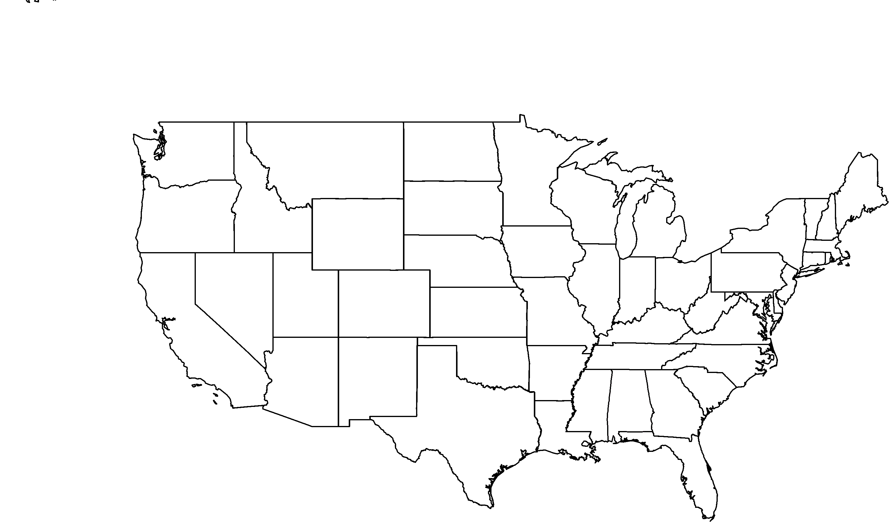

**PHOTO BY: RANCHO SANTA ANA BOTANIC GARDEN**

**About me:** I love the Central California coastal ranges so much that I don’t grow anywhere else in the world.

**Why I’m rare:** Development of buildings and roads, together with conversion of my chaparral home to non-native grasslands are the biggest threats to my existence; not to mention being trampled and munched on by grazing cattle.

**My story:** Fire helps me grow by stimulating my seeds to germinate. After a fire comes through the chaparral, I grow like crazy.

**How you can help:** Tread carefully! Protect native plant communities by staying on the trails when hiking.

**Your**

**Logo**

**Here**

Indian Valley bush mallow*Malacothamnus aboriginum*