

**About me:** I am an evergreen tree and live only in the Santa Cruz Mountains of Northern California.

**Why I’m rare:** My home is being threatened by human development and agriculture. Because fire is important for my reproduction, changes in fire frequency—especially suppression of fires—have also made it harder for me to thrive.

**My story:** My cones remain closed on my branches for many years until a fire comes through. The heat from the fire dries out the scales and the cones open to release my seeds.

**How you can help:** Help support the gardens or conservation group nearest to you. I would appreciate any help you’d be willing to offer!

Santa Cruz Cypress

*Hesperocyparis goveniana* var. *abramsiana*

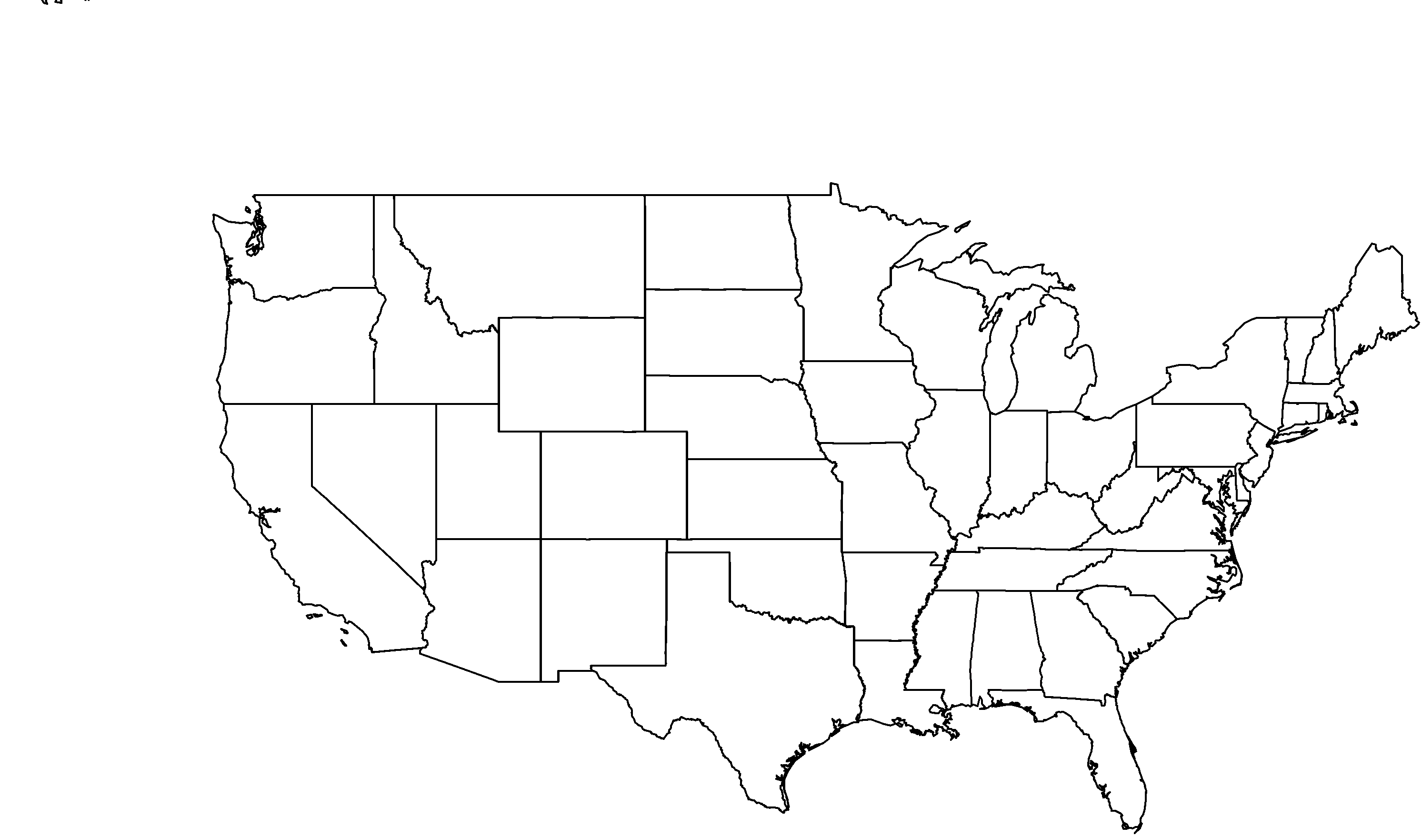

**PHOTO BY: RANCHO SANTA ANA BOTANIC GARDEN**

**Your**

**Logo**

**Here**