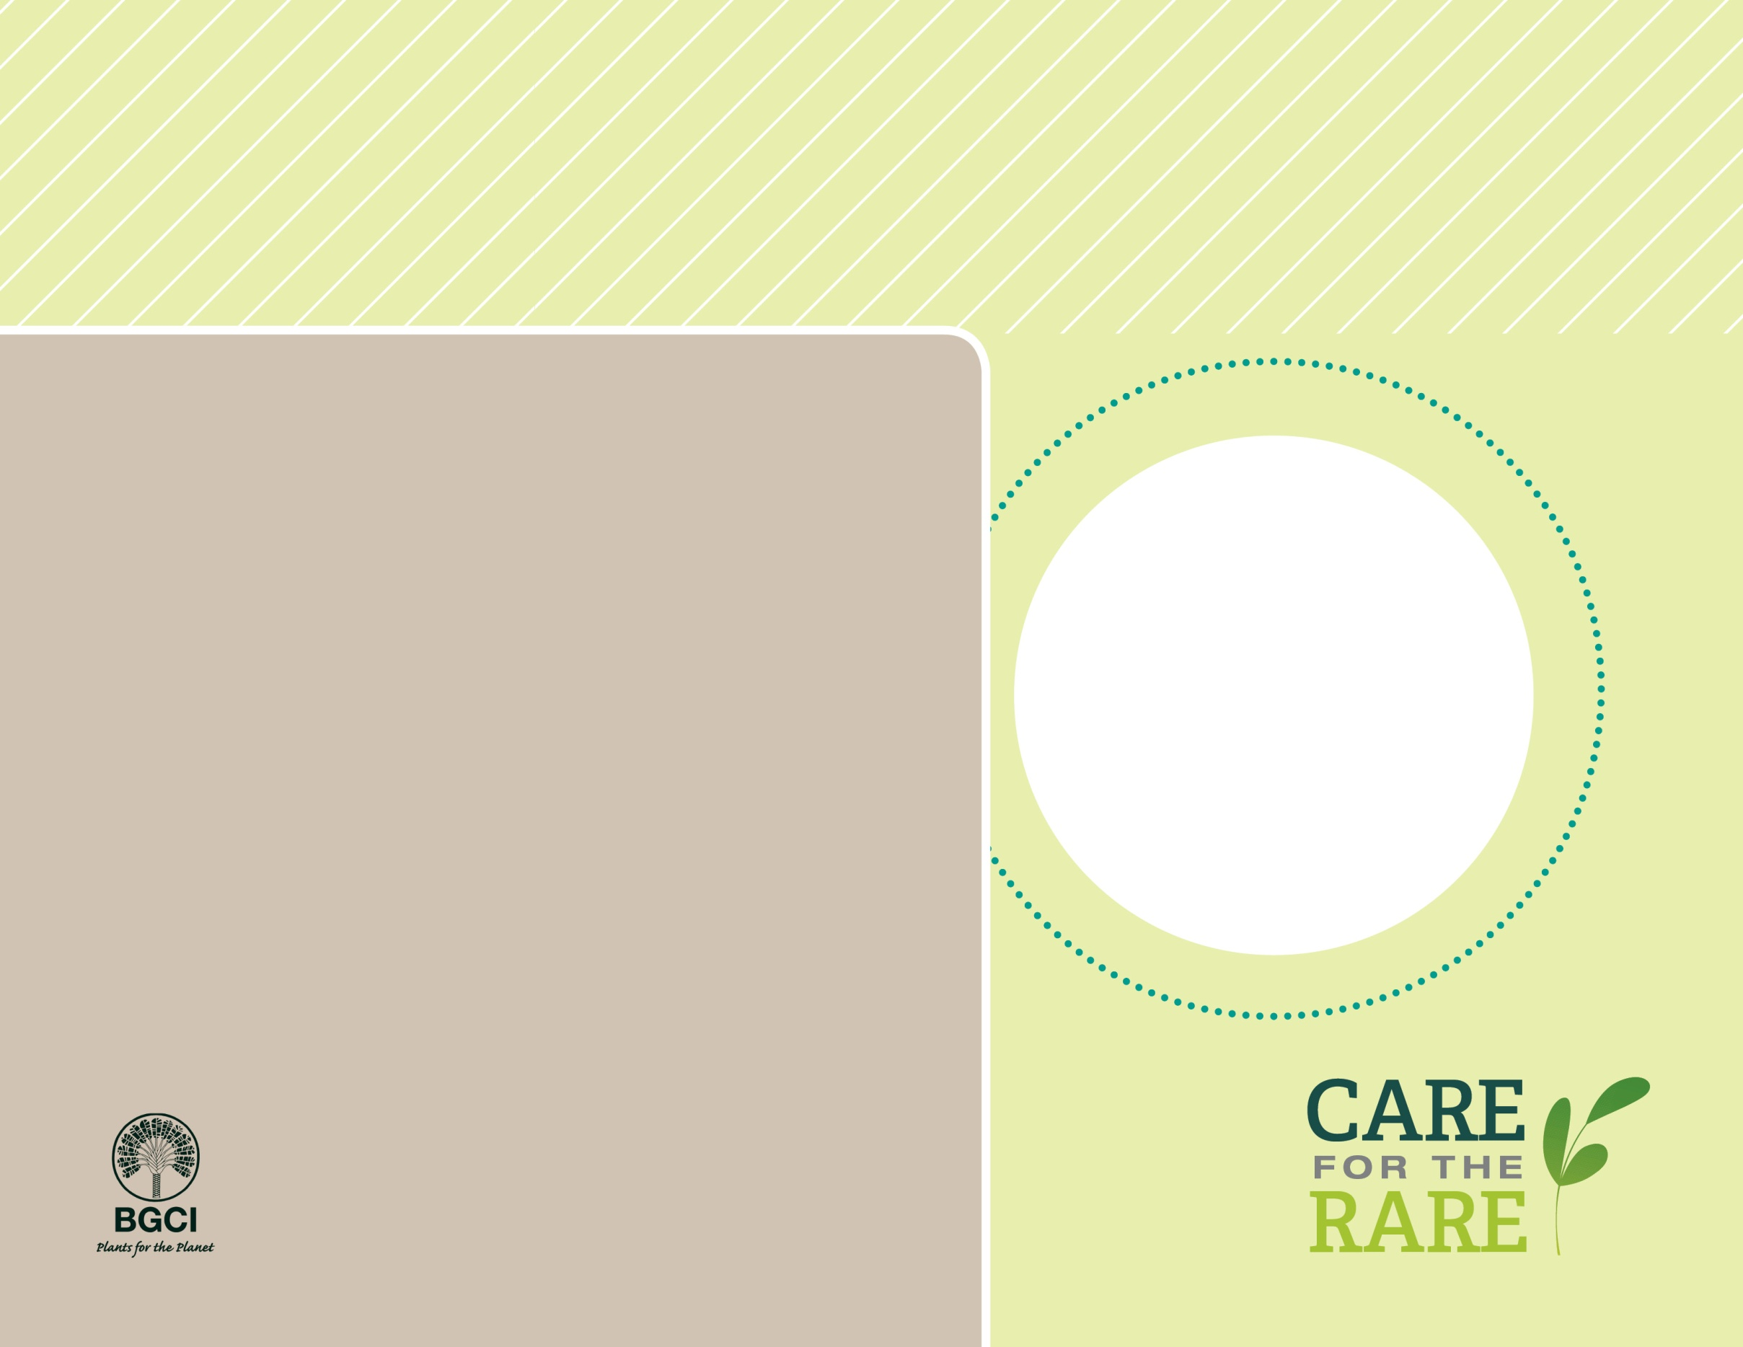

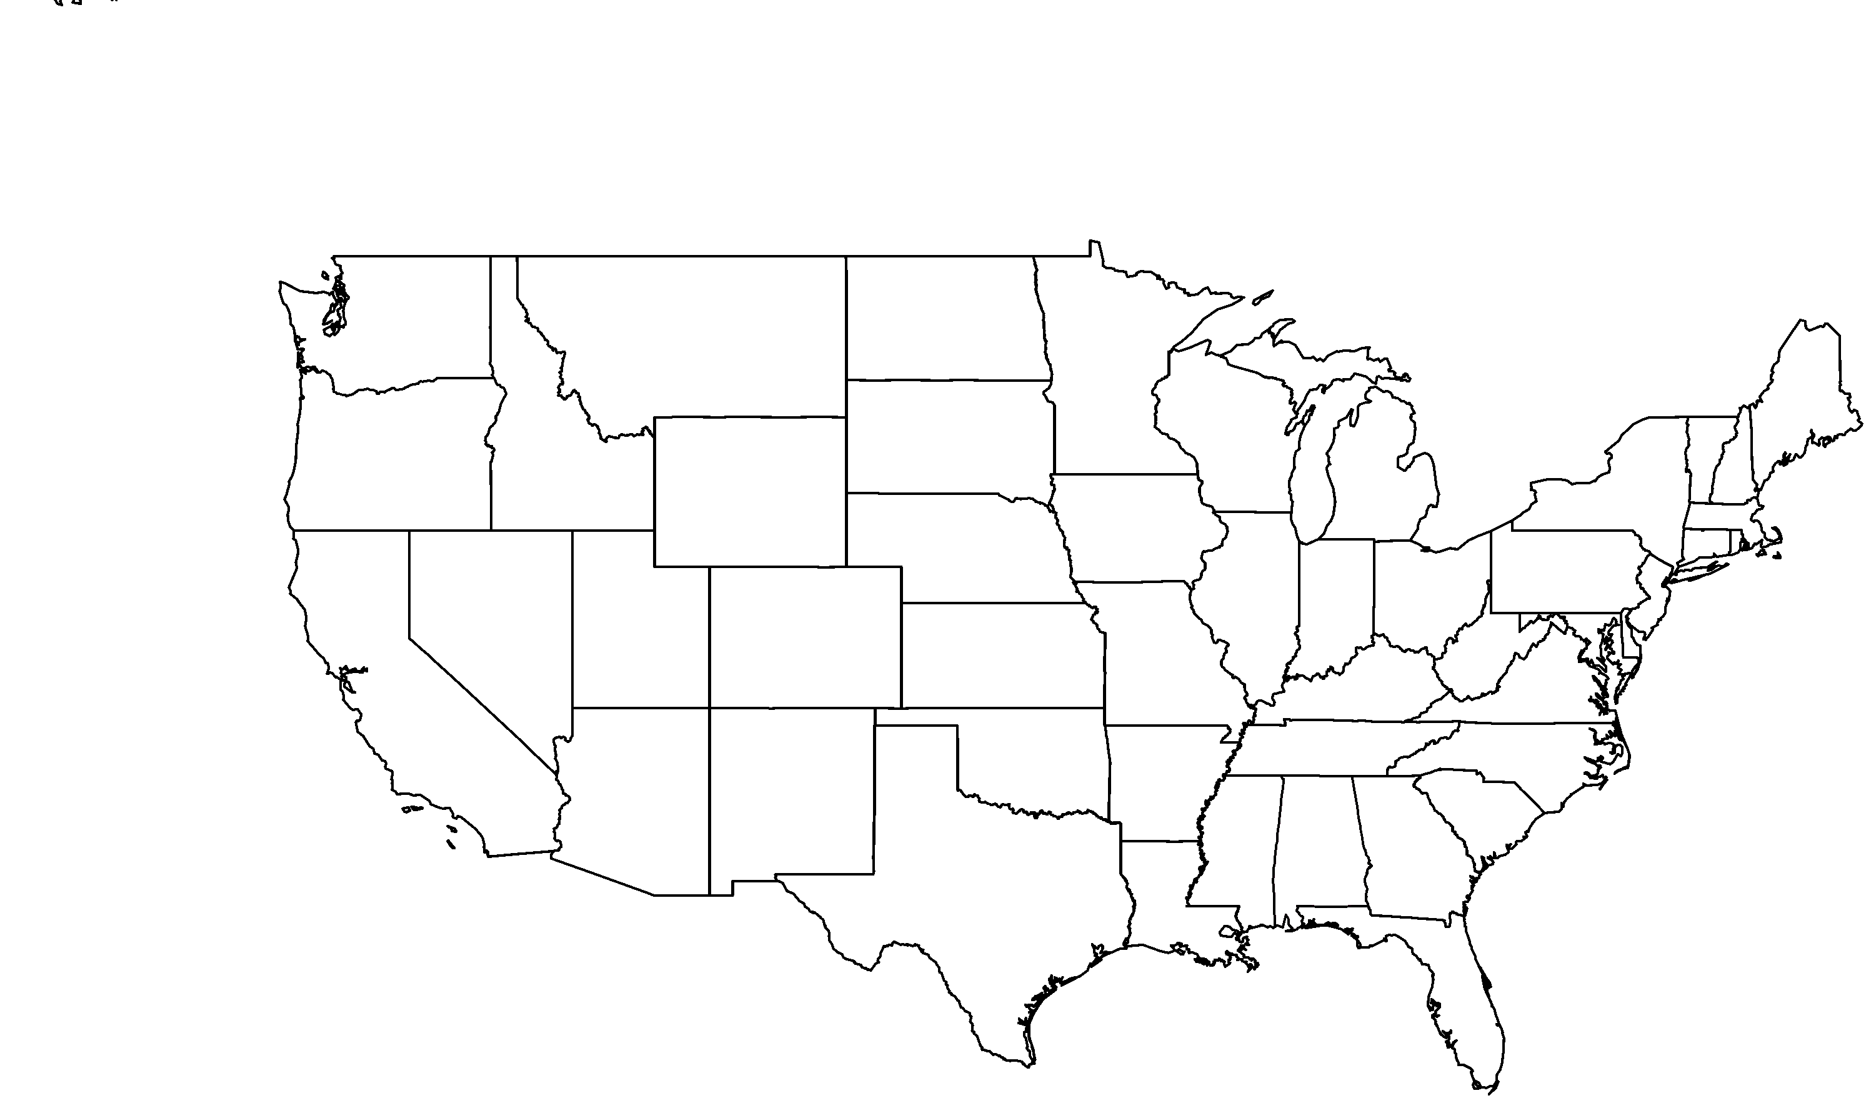

**About me:** I’m a tree native to the southeastern U.S. I have thorns on my bark and stems, just like my relative the Honey Locust, but I live in river swamps and I’m becoming increasingly uncommon in Kentucky.

**Why I’m rare:** Wetland destruction in Kentucky threatens my survival in the state. Changes in moisture in the wetlands, diminishing habitat, and increased erosion makes it more difficult for me to survive.

**My story:** I live in bayous and sloughs, and my wide, spreading root system helps stabilize soil and control erosion. I also have really strong, hard wood that is used for fence posts.

**How you can help:** Conserving wetlands with proper water and soil conditions will ensure that I have a place to live.

Photo by: Shirley Denton

Water Locust(*Gleditsia aquatica*)