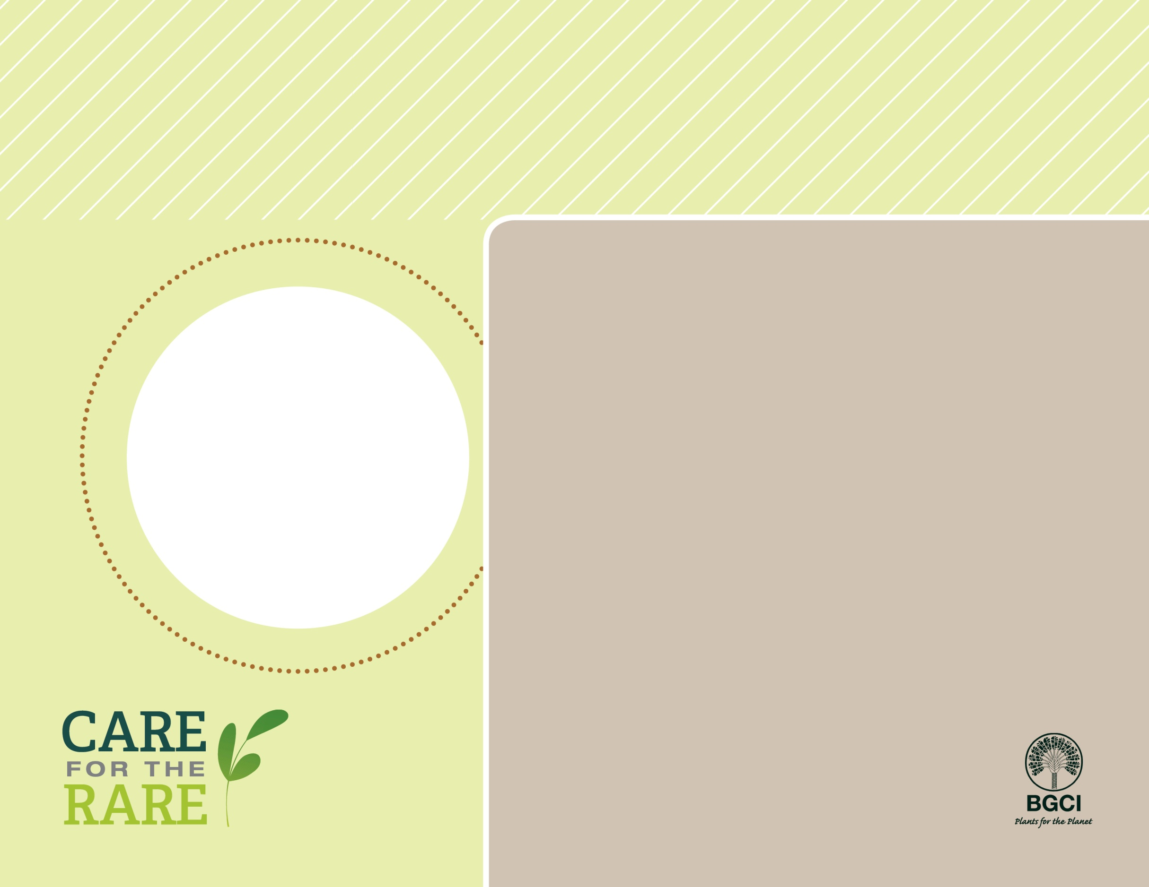

Golden barrel cactus*Echinocactus grusonii*

**PHOTO BY: UNITED STATES BOTANIC GARDEN**

**About me:** I live only in a small area of Mexico’s Chihuahuan Desert, but I’m also sold as a garden plant all over the world.

**Why I’m rare:** I’ve had trouble finding a safe place to live. A lot of the habitat where I grow best has been destroyed, and I’m often dug up illegally and sold so that people can plant me in their gardens.

**My story:** When a dam flooded my habitat, botanic gardens rescued me and helped my find a new home. They also learned how to grown me from seeds, so I don’t have to be dug up to be sold as a garden plant.

**How you can help:** Make sure all plants you buy are responsibly grown and not collected from the wild.

**Your**

**Logo**

**Here**