

Summer holly

*Comarostaphylis diversifolia* subsp. *diversifolia*

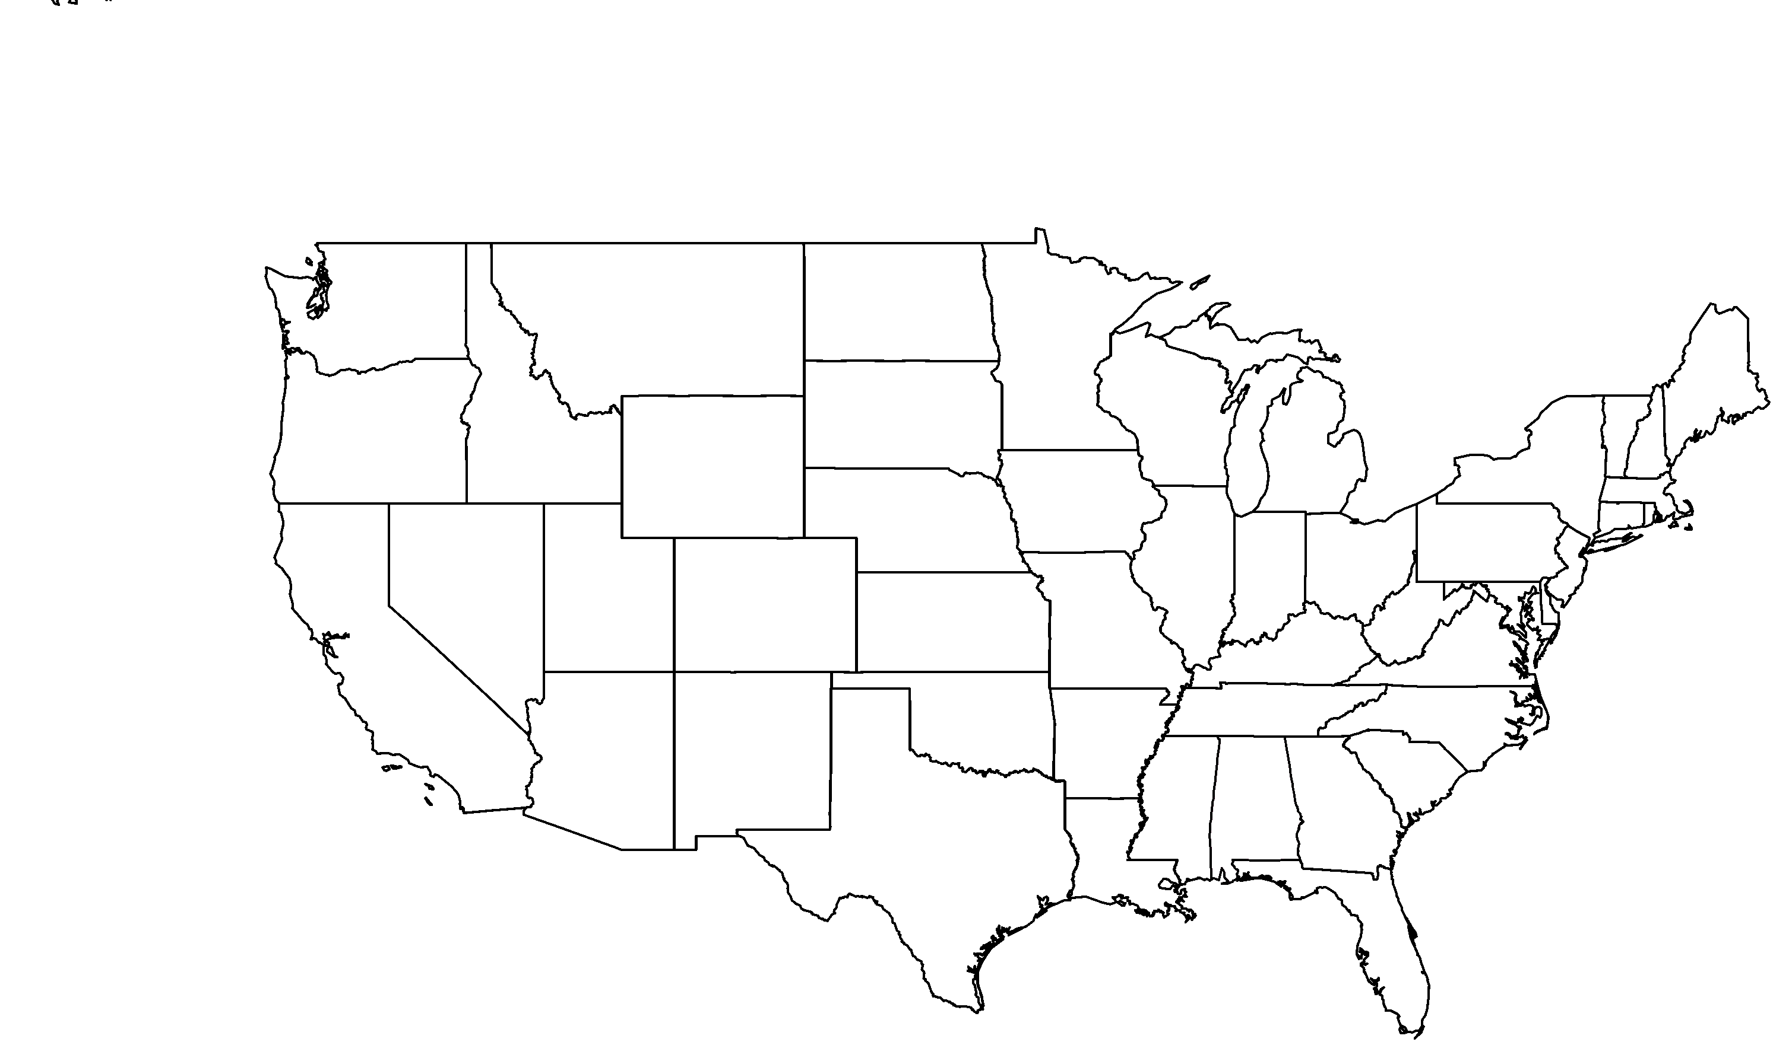

**About me:** I reside in the coastal chaparral habitat of Southern California and also parts of Northern Baja California, Mexico.

**Why I’m rare:** I continue to lose my habitat to human activities such as agricultural and residential development. Sand and gravel mining industries also threaten my home. I wish people would realize how much they are hurting me!

**My story:** My common name is summer holly because I look very similar to the non-native holly, but the difference is that I actually produce fruits in the summer.

**How you can help:** When gardening, emphasize plants that are native to your area and avoid non-natives that can become invasive in natural areas. Invasive plant species compete with native plants like me for resources and can increase the frequency and severity of fires that are very harmful to plants like me.

**PHOTO BY: RANCHO SANTA ANA BOTANIC GARDEN**

**Your**

**Logo**

**Here**