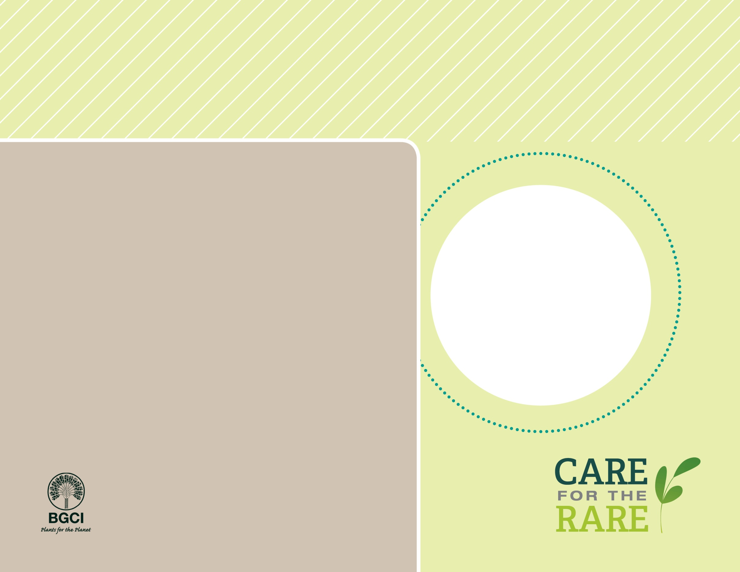

Catalina Island mountain mahogany*Cercocarpus traskiae*

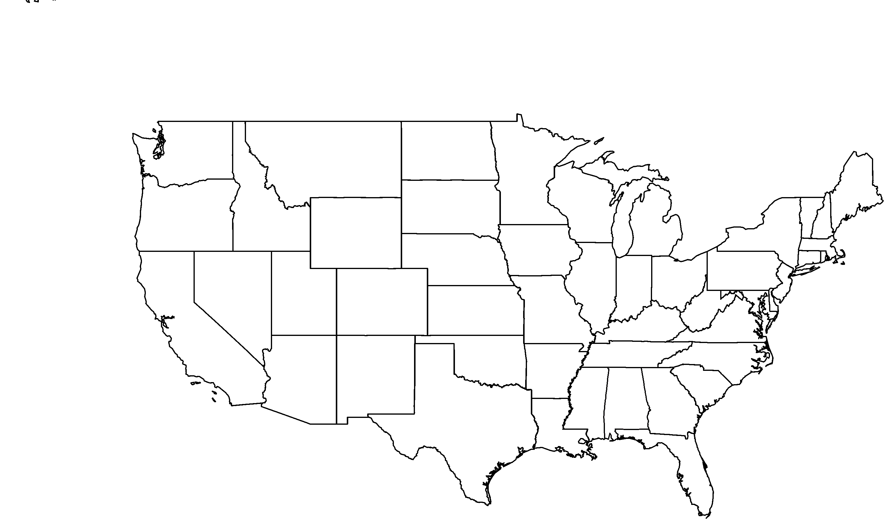

**About me:** You won’t find a tree rarer than me in California; and even in the entire U.S.—there are only seven of my kind left in the wild. We make our home in a single canyon on Santa Catalina Island, which has a very unique soil type that I seem to prefer.

**Why I’m rare:** Domestic goats, sheep, and pigs introduced to the island think I am delicious and won’t stop eating my large and lush leaves.

**My story:** Botanic gardens save genetically identical copies of most of the seven trees. With these plants, scientists are learning more about me and how I grow, so they can increase my numbers in the wild.

**How you can help:** Sadly, I am a plant of critical conservation concern, as my species will soon be extinct if I don’t get some help. You can sponsor me and contribute to conservation and restoration efforts to secure my future.

**PHOTO BY: DEAN WM. TAYLOR**

**Your**

**Logo**

**Here**