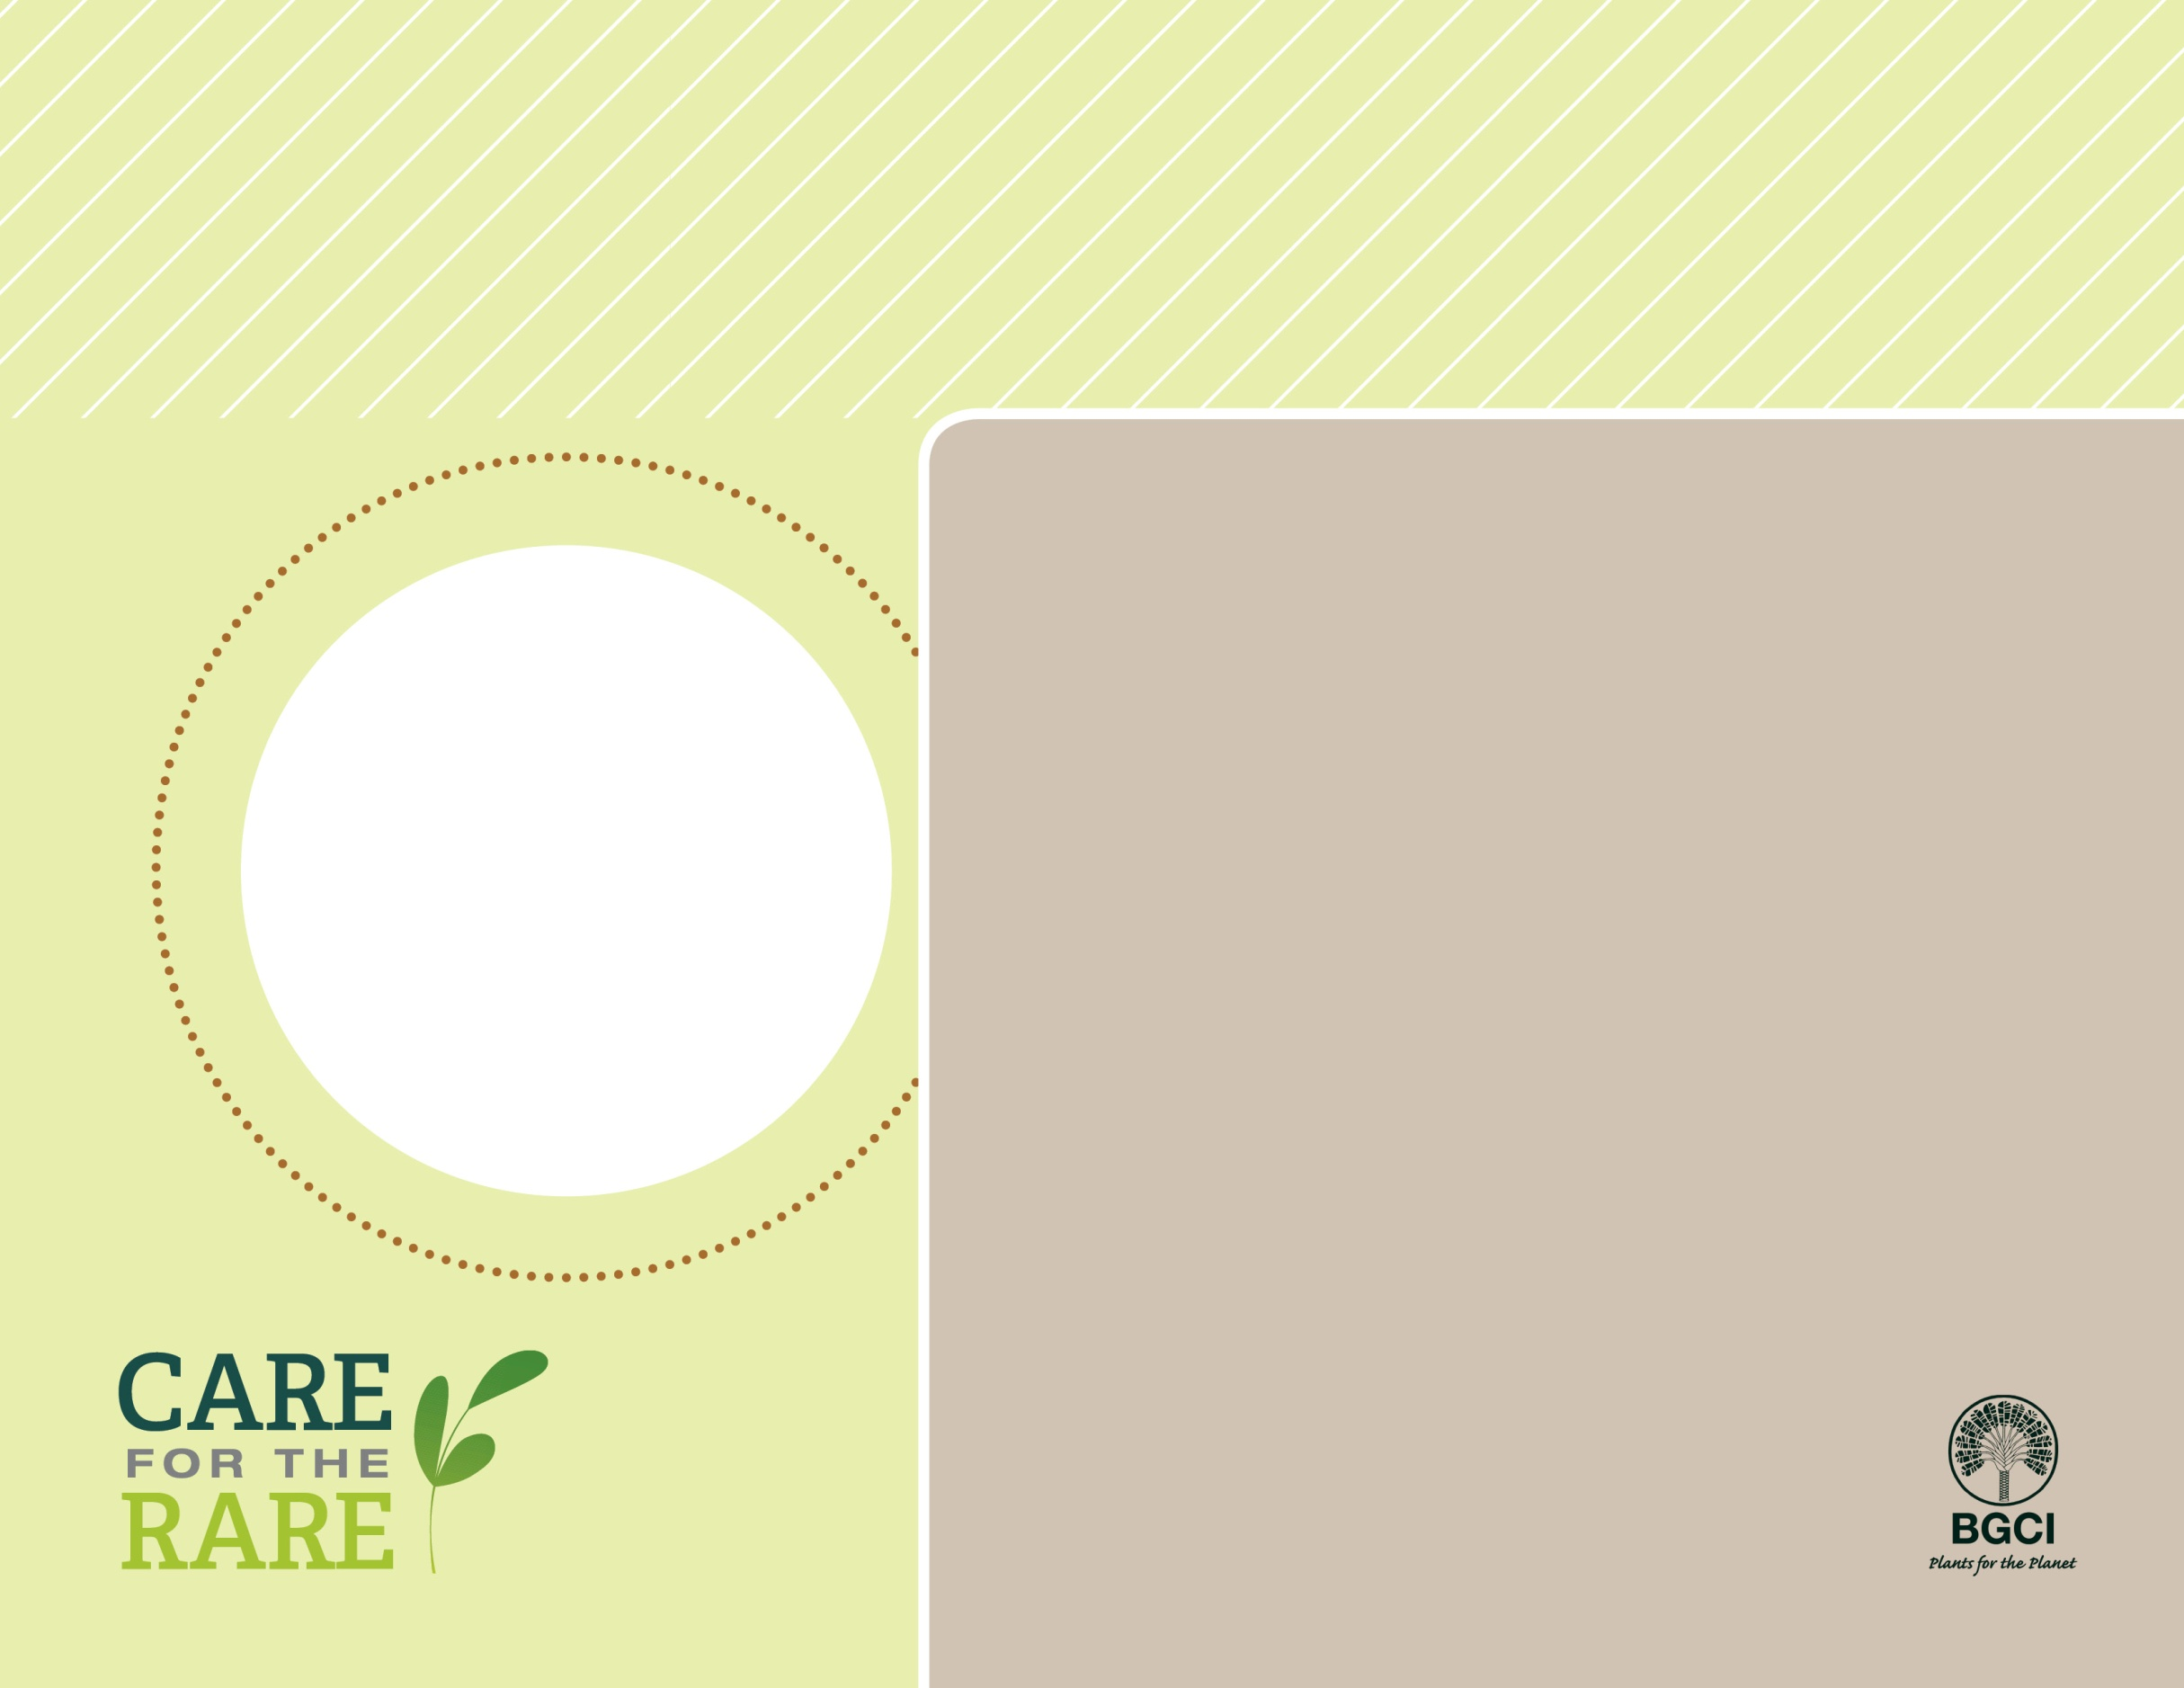

**About me:** My rounded or pyramidal shape and heart-shaped leaves make me a popular landscape tree. My leaves are extra special because they turn brilliant colors and smell sweet (burnt sugar smell) in autumn. I also have separate male and female plants.

**My story:** I am native to Japan and China, where I like moist, shady forests. I usually grow 40 to 60 feet tall in gardens, but I have reached heights of 140 feet in the wild!

**Why I’m rare:** I have trouble reproducing in the wild in China, where I am threatened by land conversion and isolation.

**How you can help:** Tell your friends about threatened species and donate or volunteer to protect native habitats near you.

**Your**

**Logo**

**Here**

Katsura tree

*Cercidiphyllum japonicum*

**PHOTO BY: DOUGLAS JUSTICE, UBC BOTANICAL GARDEN**