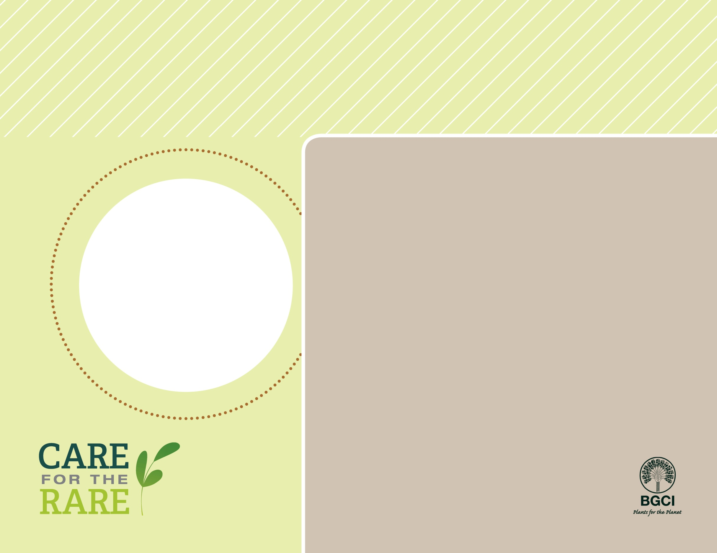

**About me:** I am a small tree found in open woods in the eastern United States. In the fall, I produce nuts that are eaten by lots of wildlife like squirrels and woodpeckers.

**Why I’m rare:** I don’t grow well in forests with too much shade, so invasive species and fire suppression are bad for me. I also have to deal with Chestnut blight, a fungus that was accidentally introduced to the United States more than 100 years ago.

**My story:** Chestnut blight caused a mass extinction of my relative (the American Chestnut) in the early 1900’s. Fortunately, I am less susceptible to this fungus and can often survive and produce nuts even when I am infected.

**How you can help:** Help preserve my habitat - support organizations that restore forests, don’t plant invasive species in your garden, and don’t transport firewood because it can spread pests and pathogens like Chestnut blight.

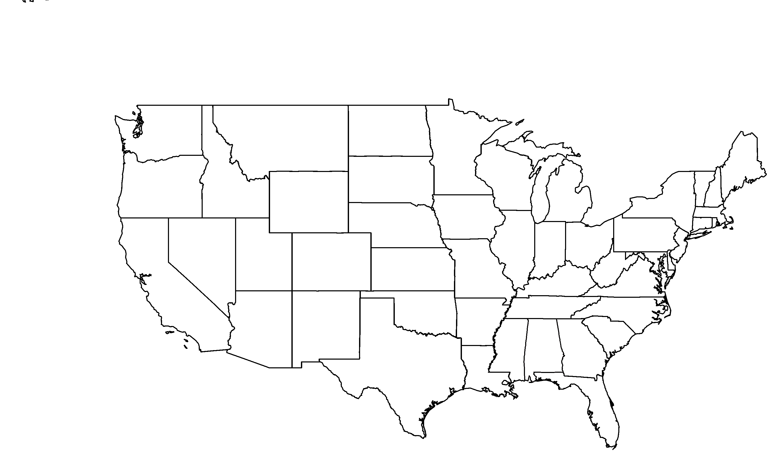

Photo by: The Arboretum

Allegheny Chinkapin(*Castanea pumila*)