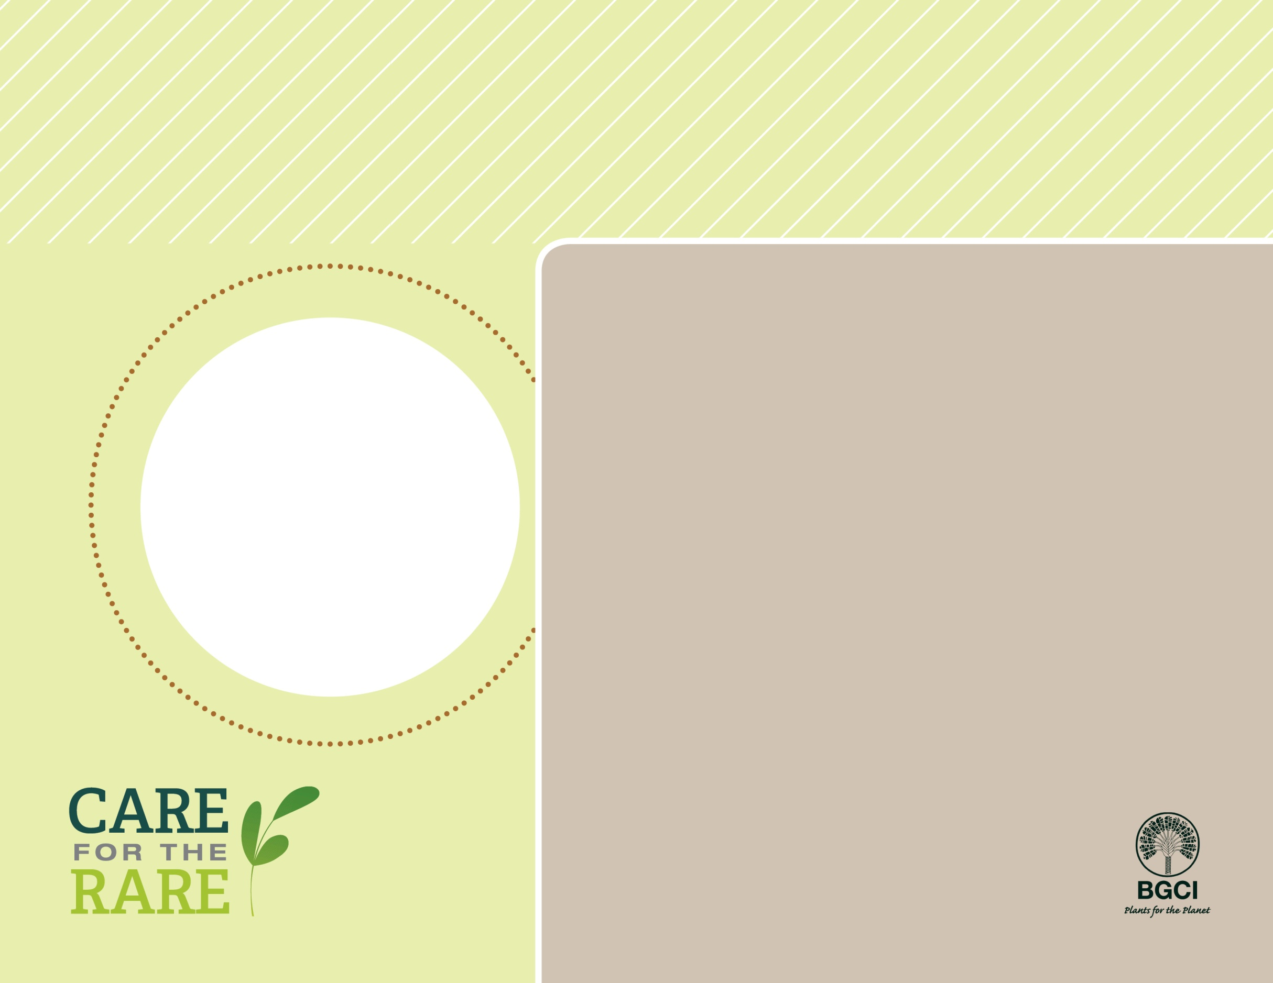

Cabbage on a stick*Brighamia insignis*

**PHOTO BY: INSERT NAME HERE**

**About me:** I call the island of Kauai my only home; my Hawaiian name is Alula. I am also grown in homes and gardens around the world.

**Why I’m rare:** Invasive species (including goats!), hurricanes, landslides and the extinction of my only pollinator have made it tough to survive. The only place I can safely grow in the wild is on steep, inaccessible cliffs.

**My story:** Hawaiian botanic gardens and others are trying to protect me from invasive species and help me produce seed (people even rappel down cliffs to hand-pollinate me!). You can also find me growing at more than 40 botanic gardens around the world, including here!

**How you can help:** Don’t “pack a pest” when you travel: fruits, vegetables, other plants and animals can carry (or become) invasive pests when brought to new places.

**Your**

**Logo**

**Here**