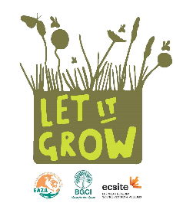
Dear Let It Grow participant,
We are coming to the close of the first year of the EAZA, BGCI & Ecsite Campaign. The campaign is well underway and we would like to hear back from the participants. In order to have a clear view of how the 2016 part of the campaign has gone, we would like to ask you to send us an update on any Let It Grow initiatives you have taken or are planning. We would love to be able to share examples of all your inspiring activities with the larger community in our various communications. Please answer the following questions and return this form via email to danielle.de.jong@eaza.net by Friday, January 20, 2017. Also please feel free to share any photos you may have. Thank you!
Sincerely,
Daniëlle de Jong
Biodiversity Communication Coordinator
European Association of Zoos and Aquaria (EAZA)

Please fill in the fields below

[Institution Name]
- Has your institution taken any initiatives for the Let It Grow Campaign in 2016? If so, please describe them below.
- Have you developed ‘left spaces’ for native biodiversity to thrive at your site? (if so, please give a short description)
- Would your institution consider hosting a Bioblitz for the campaign on May 22 2017? (for more information on Bioblitzes, visit www.letitgrow.eu )
- Could you describe the plans for any campaign initiatives in 2017?
- Has your institution cooperated with any other parties for campaign initiatives?

- What impact has Let it Grow had on your organization?

