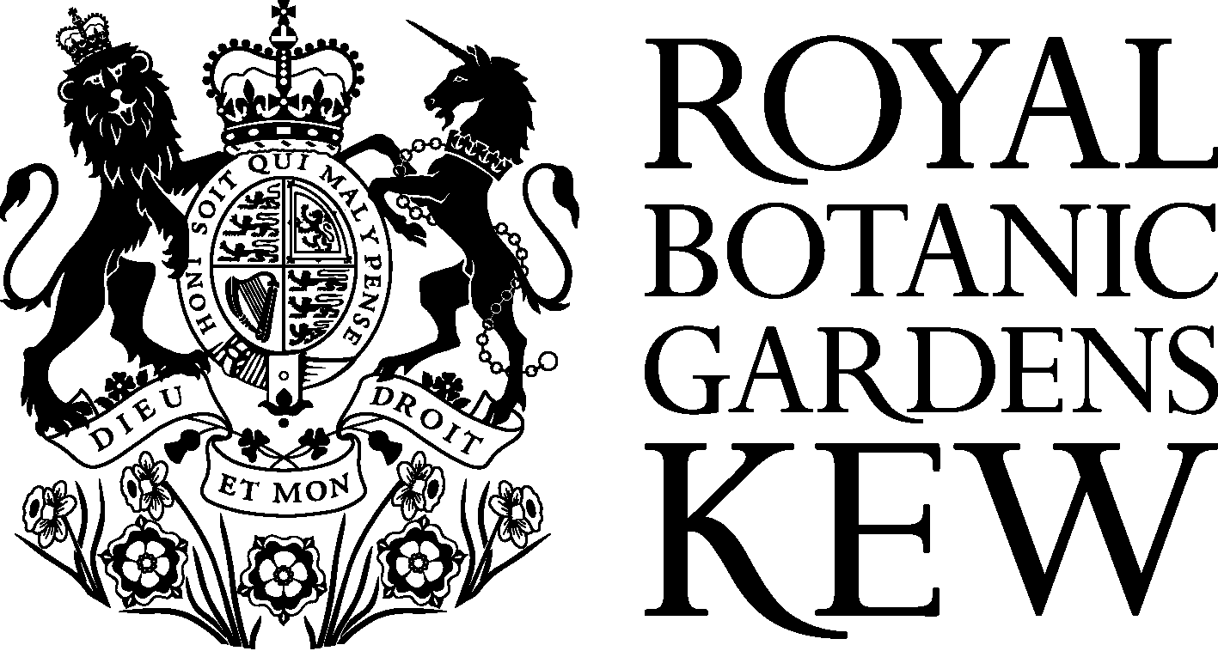
Policy on Access to Genetic Resources and Benefit-Sharing

The Royal Botanic Gardens, Kew is a non-profit, non-departmental public body whose mission is: ‘to enable better management of the Earth’s environment by increasing knowledge and understanding of the plant and fungal kingdoms - the basis of life on earth’. To achieve this mission, Kew uses its collections, and the skills of its staff, in systematics, conservation, morphology, genetics, sustainable use, horticulture and education.

Kew intends to honour the letter and spirit of the Convention on Biological Diversity (CBD), the Convention on International Trade in Endangered Species of Wild Fauna and Flora (CITES), and laws relating to access and benefit-sharing, including those relating to traditional knowledge. Kew recognises the sovereign rights of States over their own biological resources and that the authority to determine access to genetic resources rests with national governments and is subject to national legislation.
This policy covers:

1. Acquisition of genetic resources;

2. Use and supply of genetic
resources;

3. Fair and equitable sharing of
benefits arising from their use

4. Commercial use of genetic
resources;

5. Curation

6. Access to information and
associated data

Consequently, in March 2001, Kew endorsed the ‘Principles on Access to Genetic Resources and Benefit-sharing’. This document was developed by a group of 28 botanical institutions from around the world, to provide a model for best practice for the acquisition, use and supply of genetic resources. Guided by these ‘Principles’, as well as the Bonn Guidelines on Access to Genetic Resources and Benefit Sharing developed under the CBD, Kew has developed its current Policy on Access to Genetic Resources and Benefit-Sharing.

Kew is first and foremost a scientific institution. It has important collections of both living and preserved plants, plant products and botanical information. It is vital for Kew to be able to maintain and improve its collections, both in order to support taxonomic and other scientific research, and also to ensure that the levels of diversity held in ex situ collections are adequate for conservation. This Policy is designed to ensure that all material brought into Kew (either collected on fieldwork, or from other institutions and individuals) has been legally acquired on mutually agreed terms, that it is used and supplied by Kew on terms and conditions consistent with those under which it was acquired, and that benefits arising from the use of genetic resources by Kew are shared fairly and equitably as agreed with partners in the country of origin of the material.

1. ACQUISITION OF GENETIC RESOURCES

1.1 Collections strategy

In accordance with the strategy set out in its Corporate Strategic Plan, Kew acquires genetic resources by undertaking field work with partners in countries of origin. It also receives materials donated to or exchanged with Kew by other botanical institutions and individuals. Kew is committed to ensuring that all material accessioned by Kew has been legally acquired, with the prior informed consent of the country of origin.

Material collected from in situ, (field) conditions

When collecting material directly from in situ conditions (for instance on collecting expeditions), Kew staff obtain prior informed consent from the government of the country of origin, and any other relevant stakeholders (such as local landowners or Indigenous People), according to national law.

At Kew, all proposals for overseas fieldwork are peer-reviewed by the Overseas Fieldwork Committee (OFC), before permission is given to travel on behalf of Kew. The OFC checks to see that fieldworkers have set up collaborations with local partners, clarified what material they plan to collect and bring back to Kew, researched the necessary permitting procedures, and agreed terms of use and planned benefit-sharing with partners.

Kew’s priority is the legal acquisition of material through a country’s permitting procedures, following national law. In addition, Kew often uses written agreements, such as a Memorandum of Understanding, to clarify the terms of collaborations with local and scientific partners. For some projects involving access to germplasm (for example Millennium Seed Bank projects), more comprehensive Access and Benefit-Sharing Agreements are used to obtain prior informed consent from government and set out terms of access, use and benefit-sharing.

Material from ex situ conditions

Kew receives a large amount of material from ex situ conditions through exchange with other institutions, donations by academics and individuals around the world, or purchases from commercial sources. Again, the priority is to ensure this material has been legally obtained and transferred to Kew. Before accepting material from institutions or individuals that are not long-standing exchange partners, the relevant Kew department will send a standard donation letter for signature. This asks the donor to clarify that the material has been legally obtained, that they are entitled to pass the material on, that they agree to Kew’s standard uses of material, and have informed Kew of any special conditions that apply to the material.

1.2 Criteria for suppliers

Kew will not accept genetic resources from organisations and individuals if it is not satisfied that they are acting in good faith and have fulfilled both the letter and the spirit of the CBD, CITES, national laws on access to genetic resources and any relevant material transfer agreements.

2. USE AND SUPPLY OF GENETIC RESOURCES

2.1 Use strategy

Material acquired by Kew is accessioned into Kew’s permanent collections and used in the following standard ways: for research on systematics and evolutionary biology, anatomy, conservation and sustainable use by Kew staff and authorised visitors, and for display in the living collections. Such research may involve sampling DNA, pollen, spores or compounds. (set out in Kew’s Use of Material document which can be given to partners and governments so that they are able to make an informed choice when deciding whether to grant consent for access).

Kew uses material in its collections on terms that are consistent with those under which they were acquired, and where material is used by or transferred between different Kew departments any special terms (for instance from permits and agreements) are kept linked with the material. Kew aims to track the use of material among departments in order to fulfil Kew’s benefit-sharing obligations to countries of origin.

2.2 Supply strategy

As a research institution it is important that Kew is able to exchange and supply material to similar institutions for the purpose of enabling scientific research and education, as well as to meet the objectives outlines in Kew’s Corporate Strategic Plan. To help to meet these objectives, emphasis is placed on supplying genetic resources to support and build capacity for taxonomy, conservation biology and sustainable use of biological resources.

Kew supplies material in its collections on terms that are consistent with those under which they were acquired. Material is supplied to third parties for the purposes of scientific research under a standard Material Supply Agreement (MSA) which prohibits commercialisation. Any commercialisation to which Kew agrees will be subject to a separate written agreement setting out fair and equitable sharing of benefits with the country of origin of the material.

  - Loans strategy

Where Kew loans material to other scientific institutions it does so under a loan policy and agreement which prohibits commercialisation and destructive sampling.

2.4 Criteria for recipients

Kew will not supply genetic resources to organisations and individuals unless it is satisfied that they are acting in good faith and are committed to both the letter and the spirit of the CBD, CITES, national laws on access to genetic resources and any relevant material transfer agreements.

3. BENEFIT-SHARING

3.1 Benefit-sharing strategy

Kew is committed to sharing the benefits from the use of material fairly and equitably with the country of origin of the material and other stakeholders. Kew has long-term partnerships with many different institutions and countries, and works with these collaborators to develop appropriate benefit-sharing.

Increasingly, agreement on the benefits to be shared and identification of those with whom these benefits should be shared is likely to take place before access to genetic resources takes place, for instance when collecting permits are issued or collaborative agreements are signed. However, Kew also makes efforts to share benefits fairly and equitably where they arise from the use of genetic resources which were acquired before the CBD came into force or on terms that did not clarify benefit-sharing.

  - Indicative list of benefits that may be shared

Benefits that will be shared will depend on specific circumstances, and upon mutual agreement between Kew and partners. As a not-for-profit scientific institution, Kew is generally able to share non monetary benefits. The kinds of benefits that may be appropriate in different situations may include some or all of those listed below. It is important to realise that Kew will not always be able to share all of these benefits. What is fair and equitable will vary from case to case.

Benefits may include:

- Taxonomic, ecological, anatomical, biochemical, horticultural and other information, through research results, publications and educational material;
- Benefits in kind, such as augmentation of national collections in the country providing the genetic resources;
- Programmes for sharing data and images;
- The transfer of technology such as hardware, software (for instance databases) and know how;
- Training in science, in situ and ex situ conservation, information technology and management and administration of access and benefit-sharing;
- Joint research and development, through collaboration in research and training programmes, participation in product development, joint ventures and co-authorship of publications;
- Staff exchange programmes;
- Paid use of local guides, scientists and facilities;
- In the case of projects involving commercialisation, monetary benefits such as milestone payments and royalties.

3.3 Benefit-sharing mechanisms

Sharing of non-monetary benefits such as technology transfer and training is primarily accomplished through Kew’s partnerships with other institutions. The mechanism for the sharing of any monetary benefits will be mutually agreed with beneficiaries in advance, and will normally involve the transfer of funds to a nominated account. Kew is also establishing a ‘Kew Benefit-Sharing Fund’ for situations where the country of origin or provider is unknown, or where the sums involved are so small that they would be dwarfed by transaction costs.

4. COMMERCIAL USE OF GENETIC RESOURCES

Kew is a not-for-profit institution and is involved in very little commercialisation of its genetic resources. However, as part of its mission, Kew investigates plants and their constituents for taxonomic and other scientific research, and a small amount of this research may lead to the discovery of potential commercial uses of certain genetic resources.

4.1 Definition of commercialisation

‘Commercialisation’ and ‘commercialise’ shall mean: applying for, obtaining or transferring intellectual property rights or other tangible or intangible rights by sale or licence or in any other manner, commencement of product development, conducting market research, and seeking pre-market approval and/or the sale of any resulting product.

4.2 Projects leading to commercial use

A small number of Kew sustainable use projects are conceived with the aim of discovering and developing marketable products. Such projects are governed by specifically negotiated agreements with countries of origin which set out agreed terms of fair and equitable benefit-sharing in accordance with the CBD.

4.3 Pre- and post-CBD material

Kew will not Commercialise any plant or fungal material collected after the Convention on Biological Diversity came into force (29th December 1993) without the prior informed consent of the country of origin and appropriate stakeholders. Kew also undertakes to share fairly and equitably any benefits arising from such Commercialisation.

Should Kew wish to Commercialise any plant or fungal material collected before the Convention on Biological Diversity came into force (29th December 1993), Kew will, as far as is possible, share benefits fairly and equitably.
.

4.4 Commercial supply/sale of material from Kew

At present Kew’s policy is not to sell material from its collections to the general public, and not to supply material for commercial horticulture. Where material is already available in commercial trade, enquirers may be given appropriate contacts from which to source material. If material is requested for trials or new introductions, they may be advised to contact authorities in the country of origin directly to negotiate an agreement for supply for commercial purposes.

4.5 Plant Auction

As part of Kew's vital relationship with its supporters we host an annual charity Plant Auction. Only material with no restrictions on distribution under its terms of acquisition, and grown on the Kew site, is offered for auction. The auction is ticket-only and all attendees are required to sign Kew’s standard non-commercial Material Supply Agreement on entry. As well as raising much needed funds to support important heritage and conservation projects at Kew, a proportion of the monies raised (currently 10%) is put into a benefit-sharing trust fund available to support horticulture-based opportunities for staff and students from institutions in the countries of origin of the material (for example; staff training in propagation and horticultural techniques, support for threatened plant protection, recovery programmes).

5. CURATION

In order to fulfil the above obligations Kew is upgrading its curation system to record and track the acquisition, use and supply of material, and benefit-sharing activities. At present Kew’s curation system consists of a range of methods: computer databasing, barcoding of specific collections, marking specimen labels, and providing clear guidance to staff on their roles and responsibilities.

6. ACCESS TO INFORMATION AND ASSOCIATED DATA

As a scientific institution it is important that Kew makes its collections as accessible as possible to its direct scientific counterparts and to the wider scientific and conservation community. This increasingly involves the digital imaging of plant and fungal material and of associated data, and publication of much of this information in botanical databases freely available on the internet.

This policy is effective from 1 December 2004. It will be reviewed periodically. We welcome your comments on this document and how we can implement it, to help us improve our practice.
You can read this document on the internet at www.kew.org/conservation. If you do not have access to the internet or would like to see any of the documents referred to and highlighted in the text, then please email the CBD Unit at RBG, Kew: cbdunit@kew.org.

