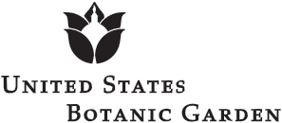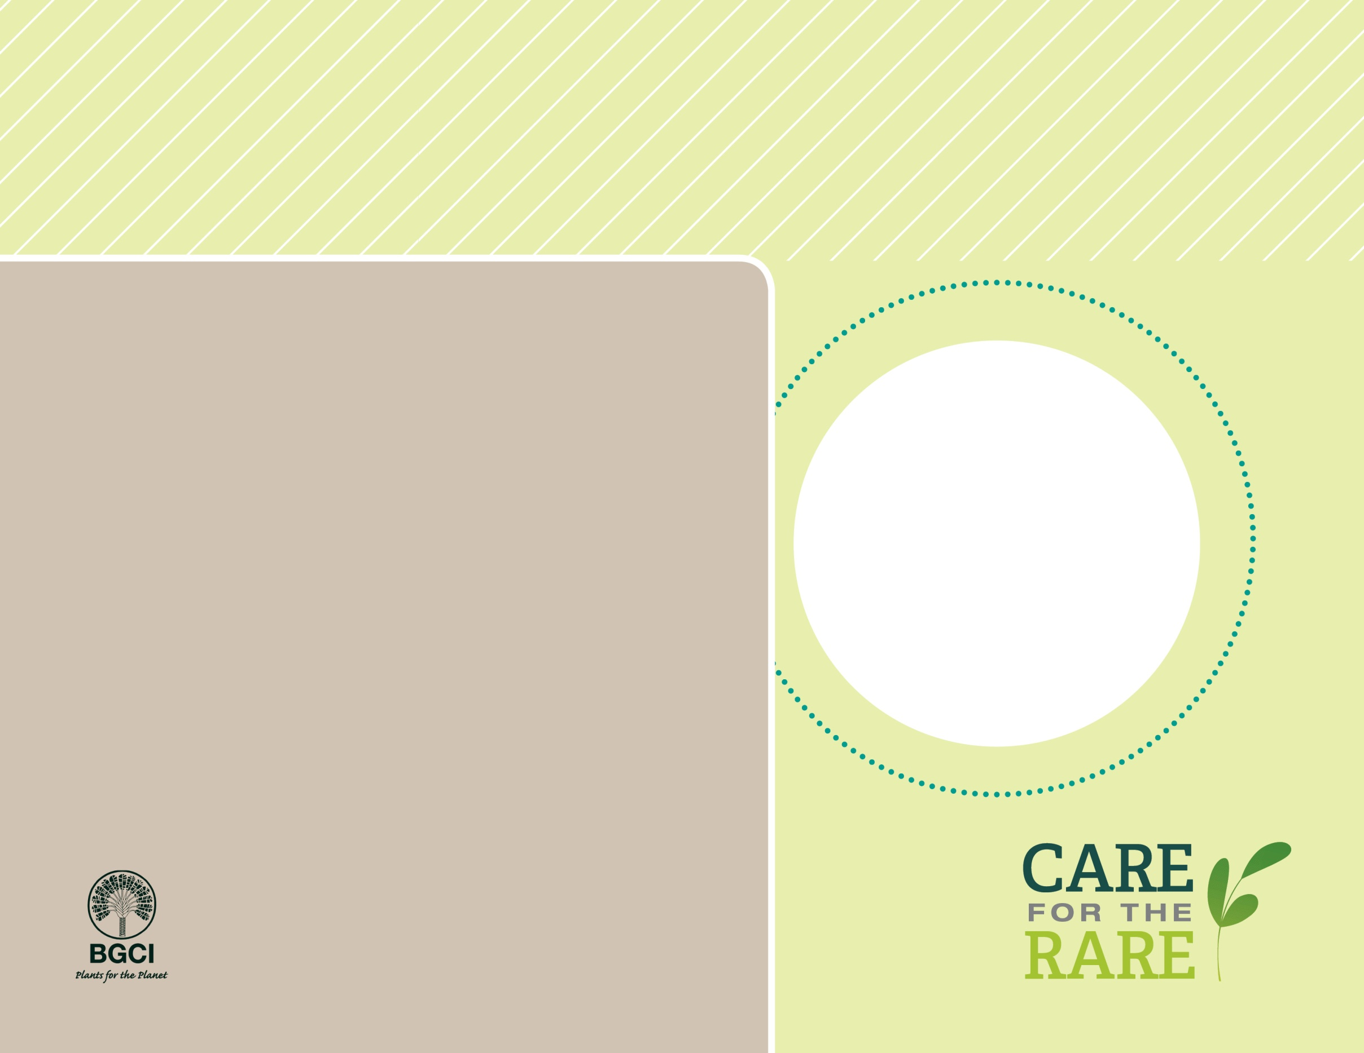

**About me:** The only place on Earth that I call my home is a very dry part of the Namib Desert on the southwestern coast of Africa. I am the only plant of my kind, and I’ve been called the ugliest plant in the world. I don’t need much water (I live mostly off of fog in the wild) and I actually provide critical water for wildlife.

**Why I’m rare:** I’m not technically threatened yet, but my populations are not producing new plants, which makes scientists worry. There are several reasons for this: a fungus damages my seeds; animals and people like to eat me; people collect me from the wild; and some people even drive off-road vehicles over me.

**My story:** I also live in more than 50 botanic gardens throughout the world. Scientists have been carefully watching me for several years. The narrow strip of land in Africa where I grow is somewhat protected from humans because of land mines.

**How you can help:** Tread lightly! Don’t drive off-road vehicles over sensitive or critical habitats, such as sand dunes and coastal areas.

Onyanga “Desert Onion”

*Welwitschia mirabilis*

PHOTO BY: JOACHIM HUBER