

**PHOTO BY: BENJAMIN SMITH**

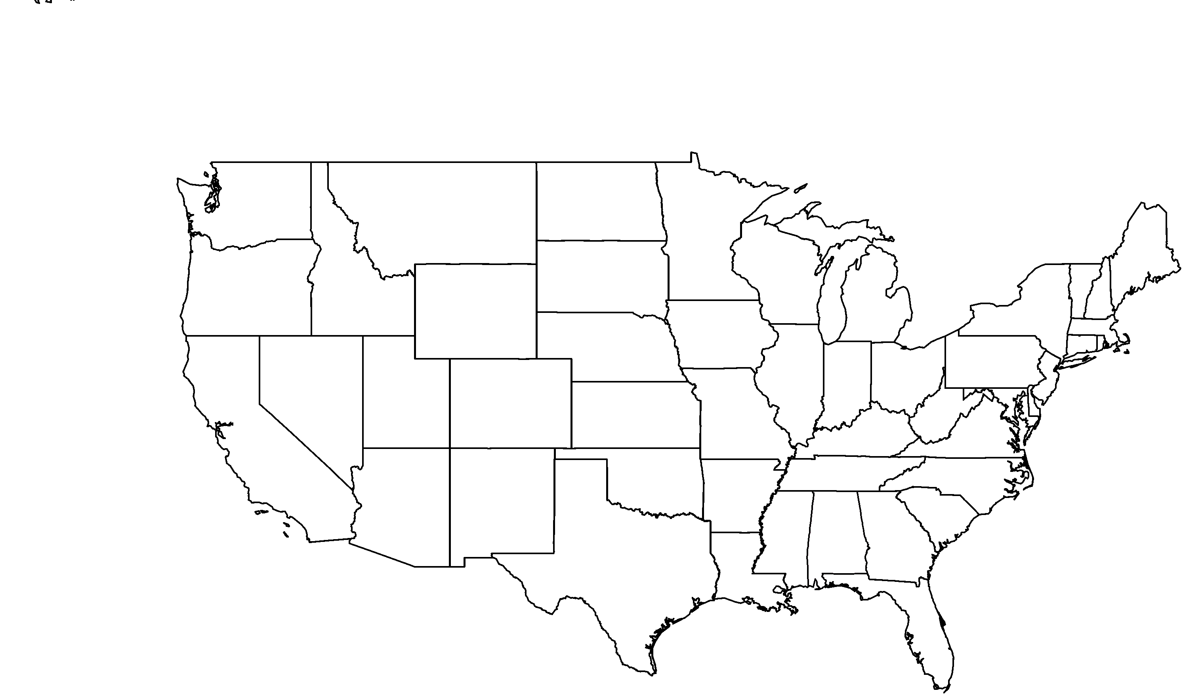

**About me:** I live only in a small part of the Laguna Beach area, but am more common in northwestern Baja California, Mexico. I can grow to be 3 to 6 feet tall.

**Why I’m rare:** My California home is popular with humans and the increasing development of residential areas threatens to eliminate my habitat. In Mexico, areas that I call home are being destroyed to make way for agriculture.

**My story:** Researchers are learning more about me. My seeds germinate readily, but I also spread by underground horizontal stems called rhizomes. These rhizomes help me survive and continue to grow after fires.

**How you can help:** When gardening, emphasize plants that are native to your area and avoid non-natives that can become invasive in natural areas. Invasive plant species compete with native plants like me for resources and can increase the frequency and severity of fire.

**Your**

**Logo**

**Here**

Bigleaf crownbeard*Verbesina dissita*