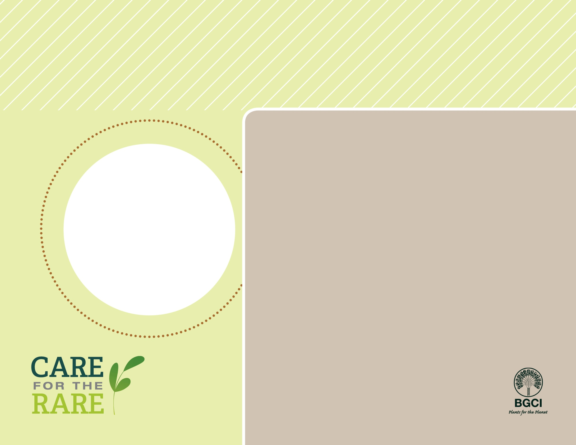

**About me:** I am one of the oldest tree species on earth with fossil records over 165 million years old.

**Why I’m rare:** I was once one of the most abundant trees in the region, but people have overharvested me for Christmas trees, riverboat fuel, shingles and fence posts, and have altered my habitat through development. A fungal disease also kills trees like me. Now there are only about 200 of me left in the wild!

**My story:** Once scattered throughout the Northern Hemisphere, I was driven south by glaciers that once covered the northern states. Now I live in small, isolated pockets in the southeastern United States.

**How you can help:** The Atlanta Botanical Garden and the State Botanical Garden of Georgia are monitoring existing populations and are producing new trees to return to these protected sites. You can help by supporting threatened plant protection, research, monitoring and reintroduction efforts both here and at your local garden.

Stinking Cedar(*Torreya taxifolia*)

PHOTO BY: MICHAEL WENZEL