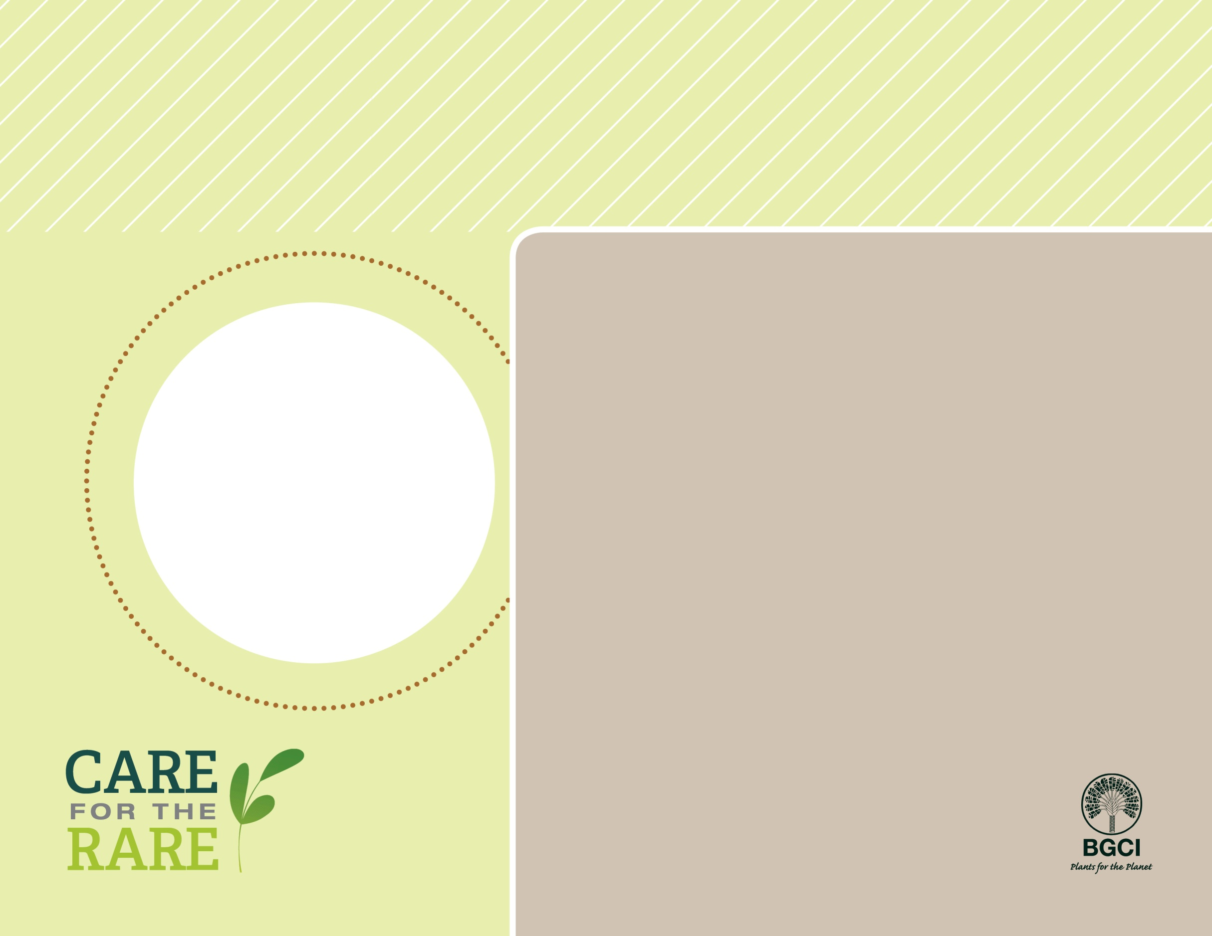

Brandegee’s Sage

*Salvia brandegei*

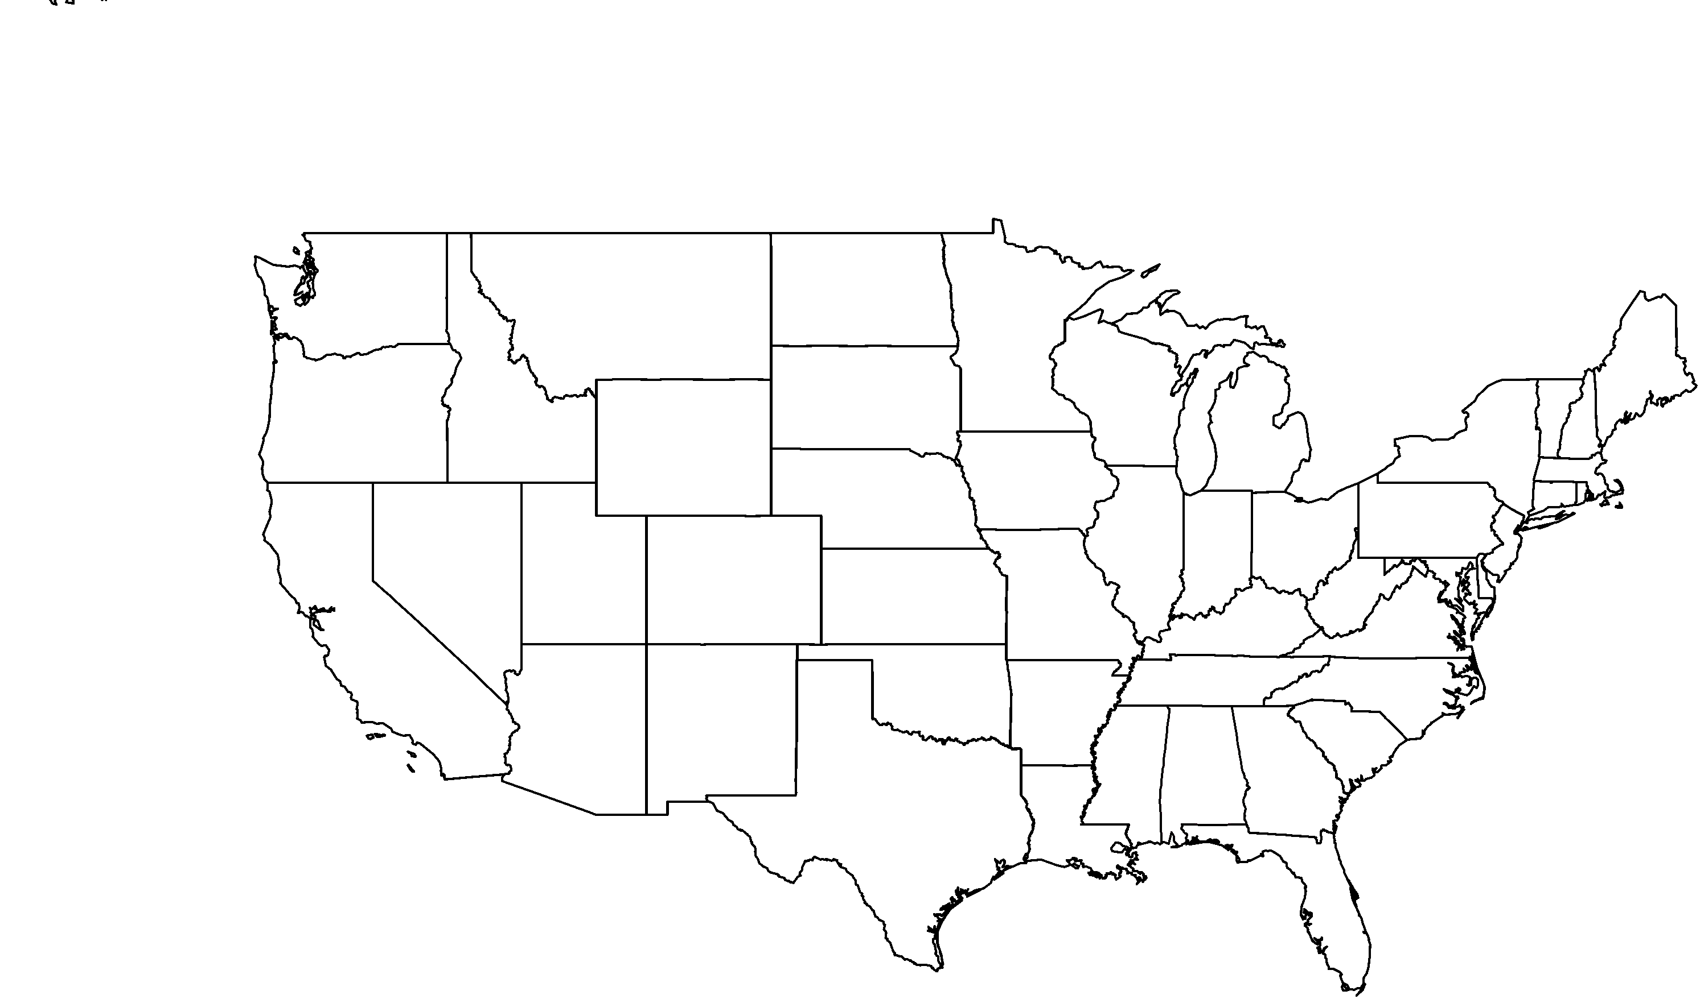

**PHOTO BY: SCOTT ZONA**

**About me:** Named after an early American botanist, I am a beautiful sage with shimmering, blue flowers. I love the full sun, dry conditions, and will grow in clay or sandy soil. I live on Santa Rosa Island and in coastal areas of northwestern Baja California.

**Why I’m rare:** On Santa Rosa Island, trampling by non-native cattle and elk makes it extremely difficult for me to survive and grow.

**My story:** Thanks to restoration efforts on Santa Rosa Island, my numbers are now recovering! Like all sages, I am extremely fragrant and I’m sure you’ll think I smell great.

**How you can help:** Help support local botanic gardens that conserve and preserve California’s native flora by donating, becoming a member, or even volunteering.

**Your**

**Logo**

**Here**