

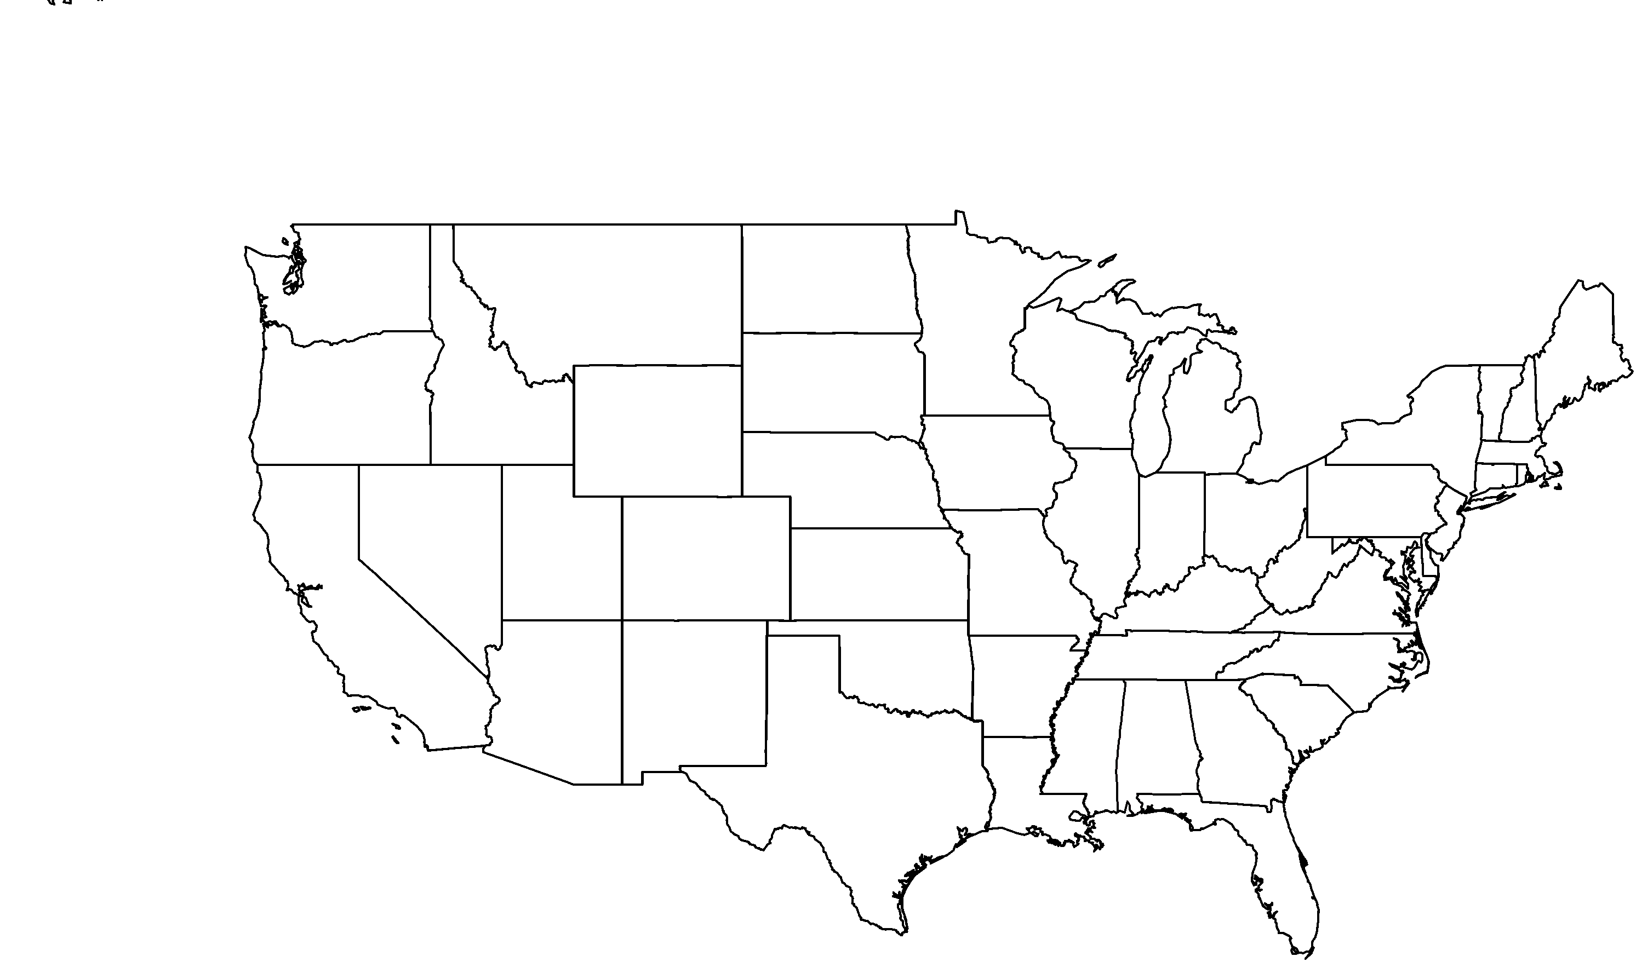

**PHOTO BY: RANCHO SANTA ANA BOTANIC GARDEN**

**About me:** I have rosy pink flowers and little leaves (hence my name!)

**Why I’m rare:** I was probably always rare in California. My home on the Otay Mesa in San Diego County was destroyed to make way for a housing development. Although I am extinct in the wild in California, I still grow along the coast of northwestern Baja California in Mexico.

**My story:** I am drought tolerant and can go as long as nine months without water. In the summer I lose my leaves, which helps me conserve water to survive extended periods of drought.

**How you can help:** Water is a limited resource for both plants and humans. Help conserve water by watering your garden in the morning or evening when it’s cooler to minimize evaporation.

**Your**

**Logo**

**Here**

Small leaved rose*Rosa minutifolia*