

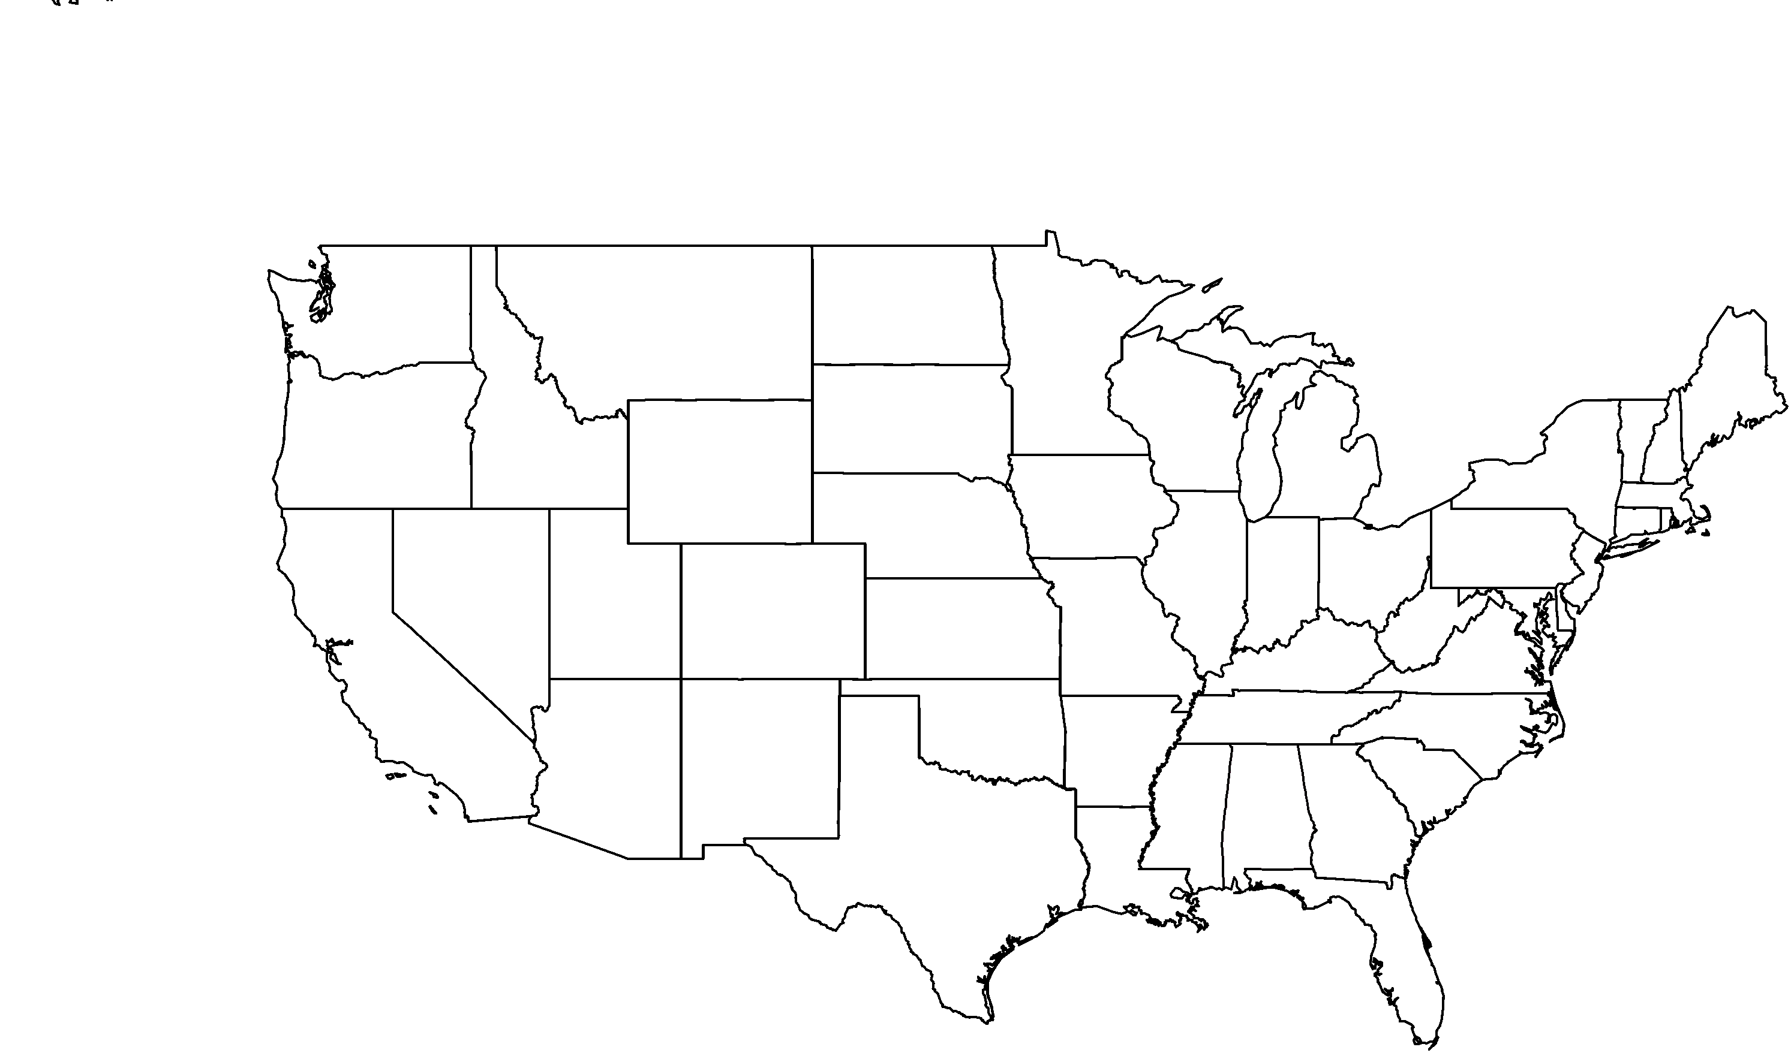

**About me:** Millions of years ago, I lived on the California mainland, but now my wild home is limited to the Channel Islands and Guadalupe Island, located off the west coast of Mexico’s Baja California.

**Why I’m rare:** Overgrazing by introduced animals such as mule deer, feral pigs, goats, and American bison have led to habitat degradation and soil erosion. These animals also eat my acorns, graze on my seedlings and even trample me.

**My story:** Goats on Guadalupe Island has been pretty successful and fences have been built to encourage regrowth!

**How you can help:** When gardening, emphasize plants that are native to your area and avoid non-natives that can become invasive into natural areas like my home, where they compete with native plants like me for resources and can also increase the frequency and severity of fire.

**PHOTO BY: BRI WELDON, RANCHO SANTA ANA BOTANIC GARDEN**

Island oak*Quercus tomentella*

**Your**

**Logo**

**Here**