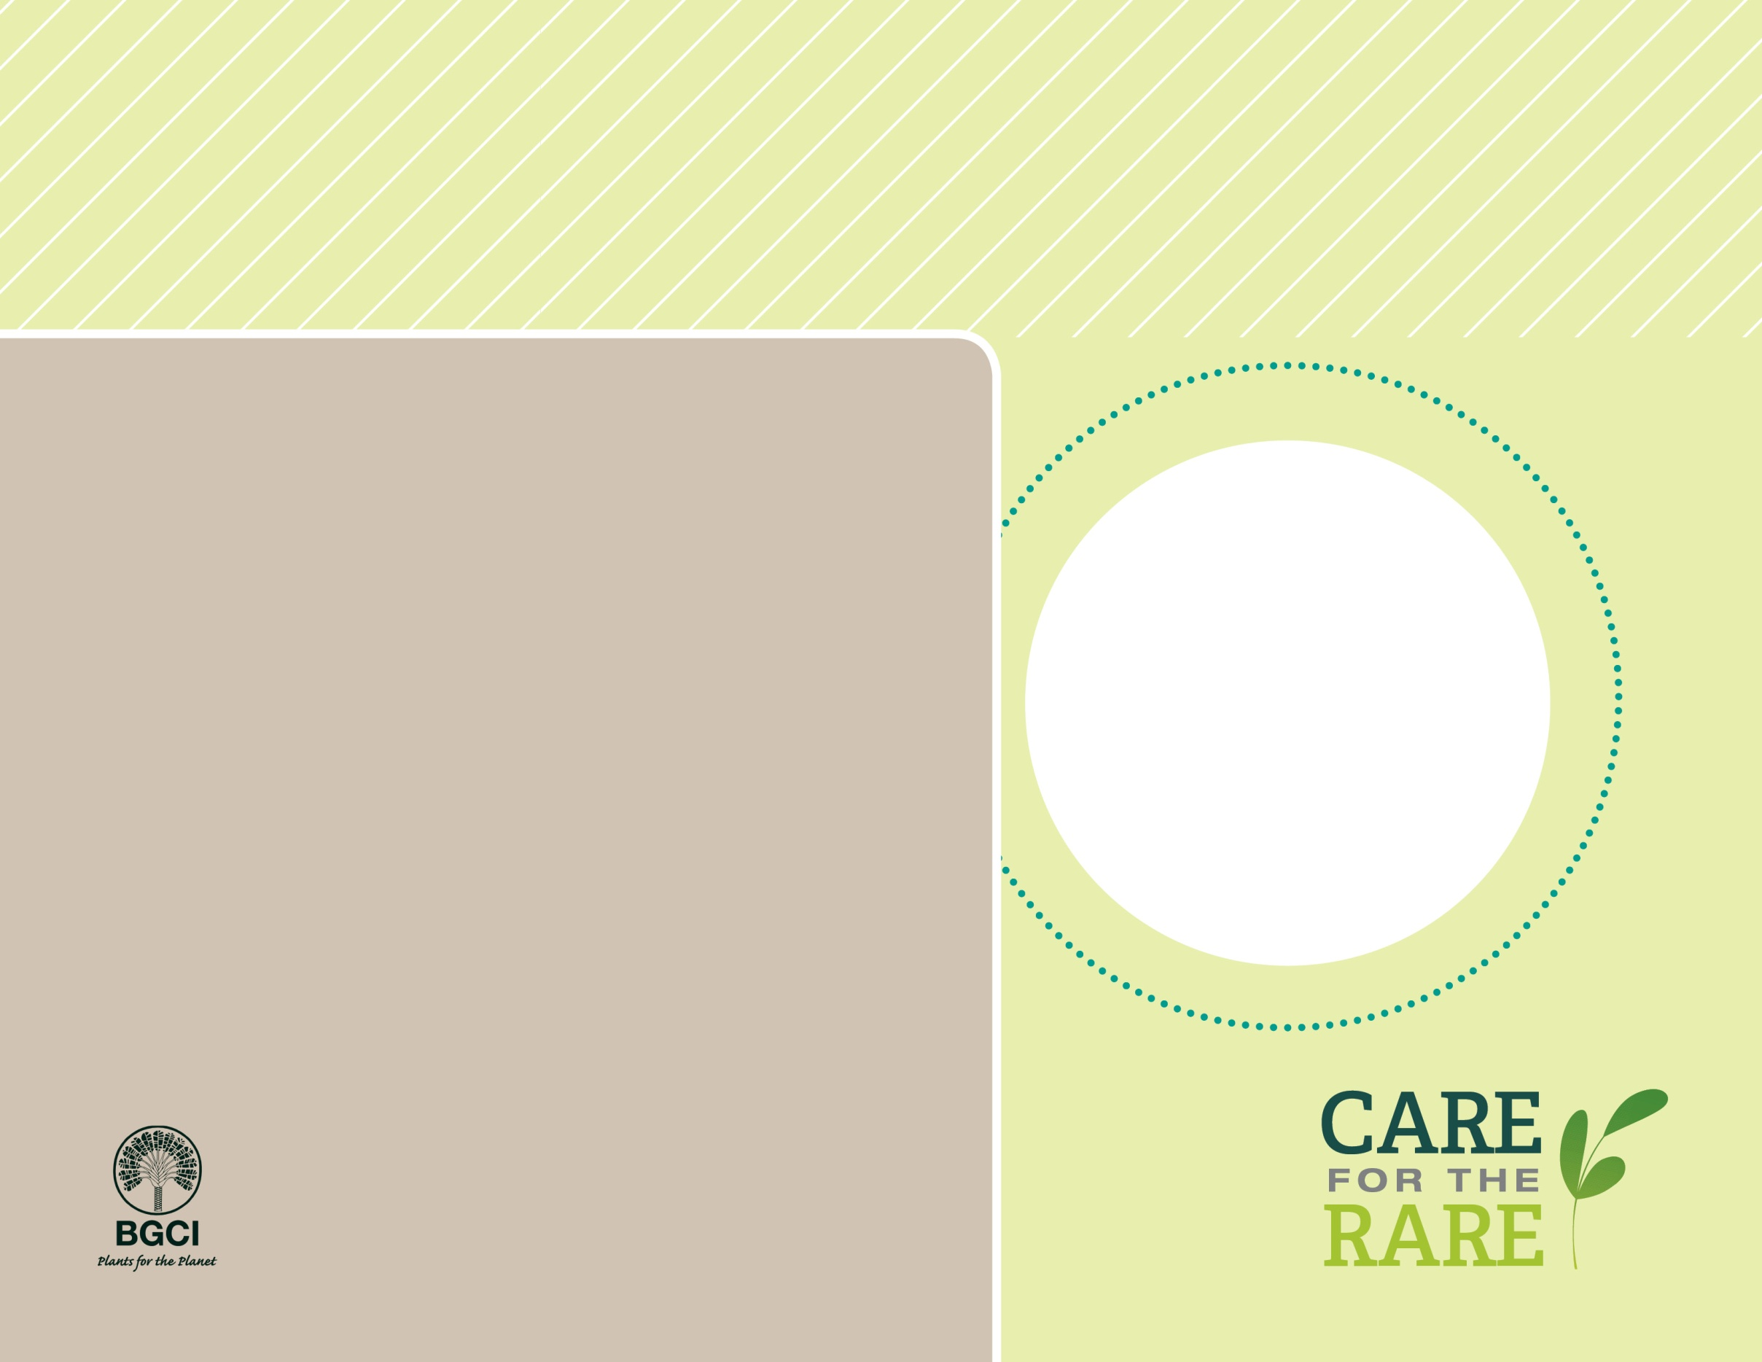

**About me:** I am truly one of a kind! Scientists call me a 'living fossil' because I lived on Earth during the time of dinosaurs. I am the only living evolutionary connection between ferns and conifers.

**Why I’m rare:** I have suffered in the wild probably from widespread deforestation in my native home in China.

**My story:** For centuries, I have been an important cultural symbol, food, and medicine throughout Asia. Now my leaves are used to treat symptoms of Alzheimer’s disease and many other ailments. Traditionally planted in temple gardens in China and Japan, I have been a popular garden tree for centuries. This has probably helped to save my kind from extinction.

**How you can help:** Plant rare trees like me in your yard if you have the space, and donate or volunteer to help protect native habitat and plants near your home.

**Your**

**Logo**

**Here**

**PHOTO BY: DR. PING ZHANG**

Maidenhair tree*Ginkgo biloba*