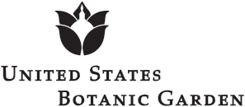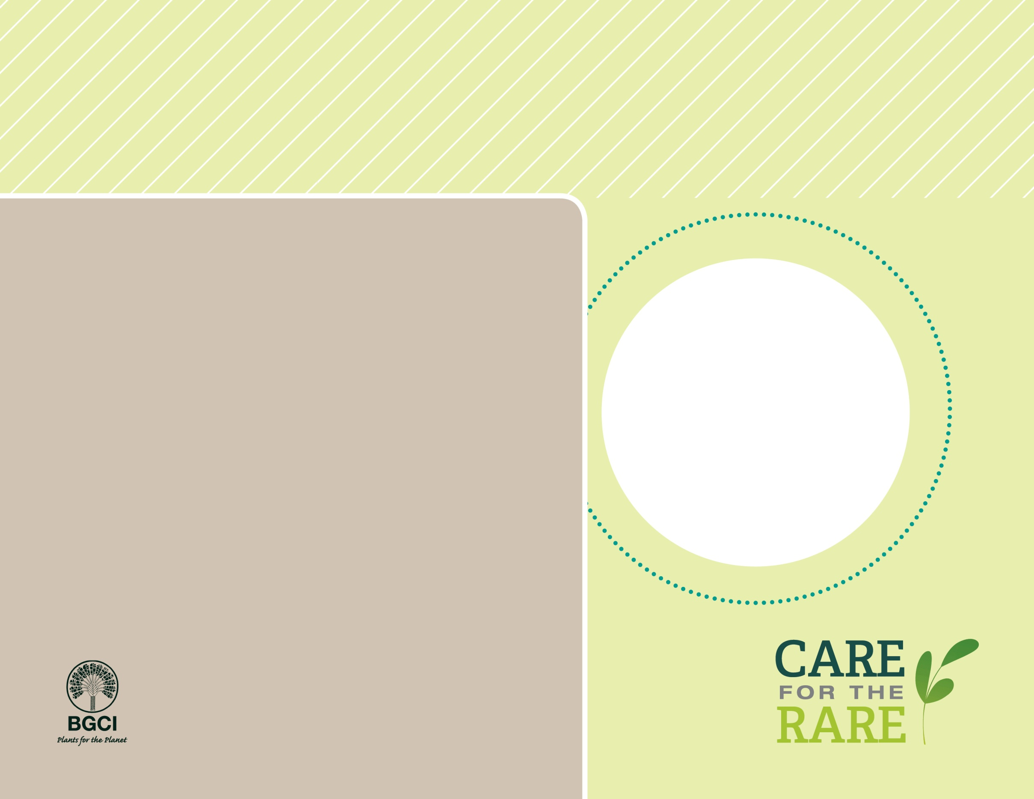

**About me:** I am called the baseball plant because of my round shape and ribbed edges. I am only found in the Great Karoo desert of South Africa.

**Why I’m rare:** I’m endangered because of unsustainable harvesting by collectors and plant exporters. Thanks to new national and international laws, my remaining populations are protected.

**My story:** While I am endangered in my native habitat, I am becoming very common in cultivation. With increasing cultivation, nurseries and botanical gardens ensure that I don’t have to be harvested from the wild to be grown in people’s homes.

**How you can help:** Support efforts that protect threatened and endangered species like me to ensure that I’m around in the future.

Baseball Plant

(*Euphorbia obesa*)

PHOTO BY: KARELJ