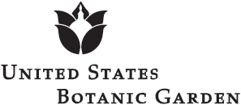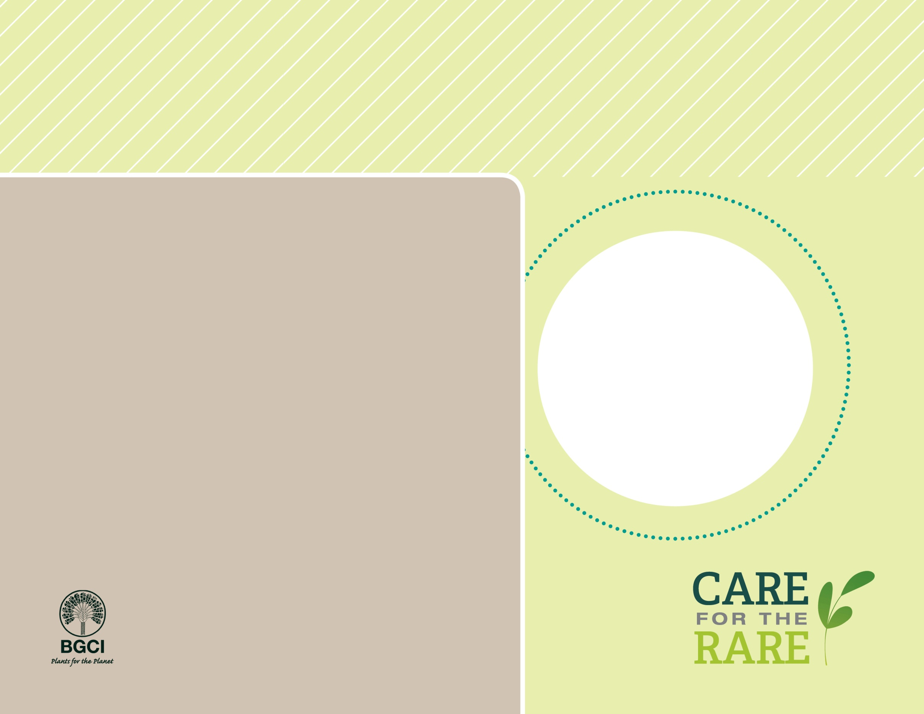

**About me:** I eat insects! I am a carnivorous plant that lives in sandy, acidic, low-nutrient soils in bogs along the border of North and South Carolina.

**Why I’m rare:** Because I’m a popular household plant, I’m vulnerable in the wild. My populations are declining due to illegal harvesting, which damages my habitat and reduces genetic diversity of my species.

**My story:** Living in a low-nutrient environment, I rely on insects to help me survive. My adapted leaves close and “trap” insects when anytwo hairs on my leaves are touched.

**How you can help:** Make sure you purchase plants that are not harvested from the wild. Buy plants labeled as “nursery propagated” or cultivated varieties such as “Giant” or “Royal Red.”



Venus Fly Trap

*Dionaea muscipula*

PHOTO BY: NOAH ELHARDT