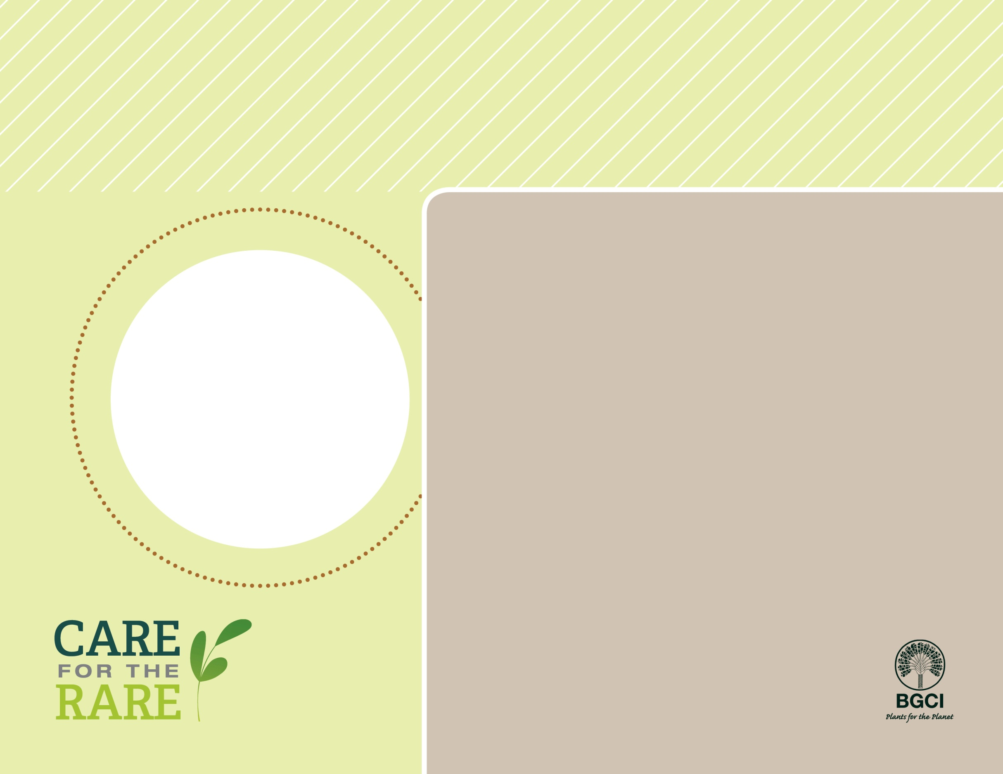

**About me:** I am one of the most primitive plants on Earth and I am not actually a palm! I am a cycad native to southern Japan. My beautiful leaves are very poisonous if eaten by any animals (including humans). However with special treatment my pith is an edible starch called sago, a popular food grown in the East Indies.

**Why I’m rare:** Collection of my seeds and decorative leaves, plus agricultural development in my native home has threatened my numbers in the wild.

**My story:** I am an extremely popular ornamental plant and survive outdoors in warm climates or indoors in colder areas. Like all cycads I am dioecious, meaning that I have both male and female plants.

**How you can help:** Volunteer or donate to protect native plants and habitats near your home, and always buy plants that have NOT been collected from the wild.

**Your**

**Logo**

**Here**

Japanese sago palm

*Cycas revoluta*

**PHOTO BY: YVES LANCEAU, PHOTOSHOT LTD**