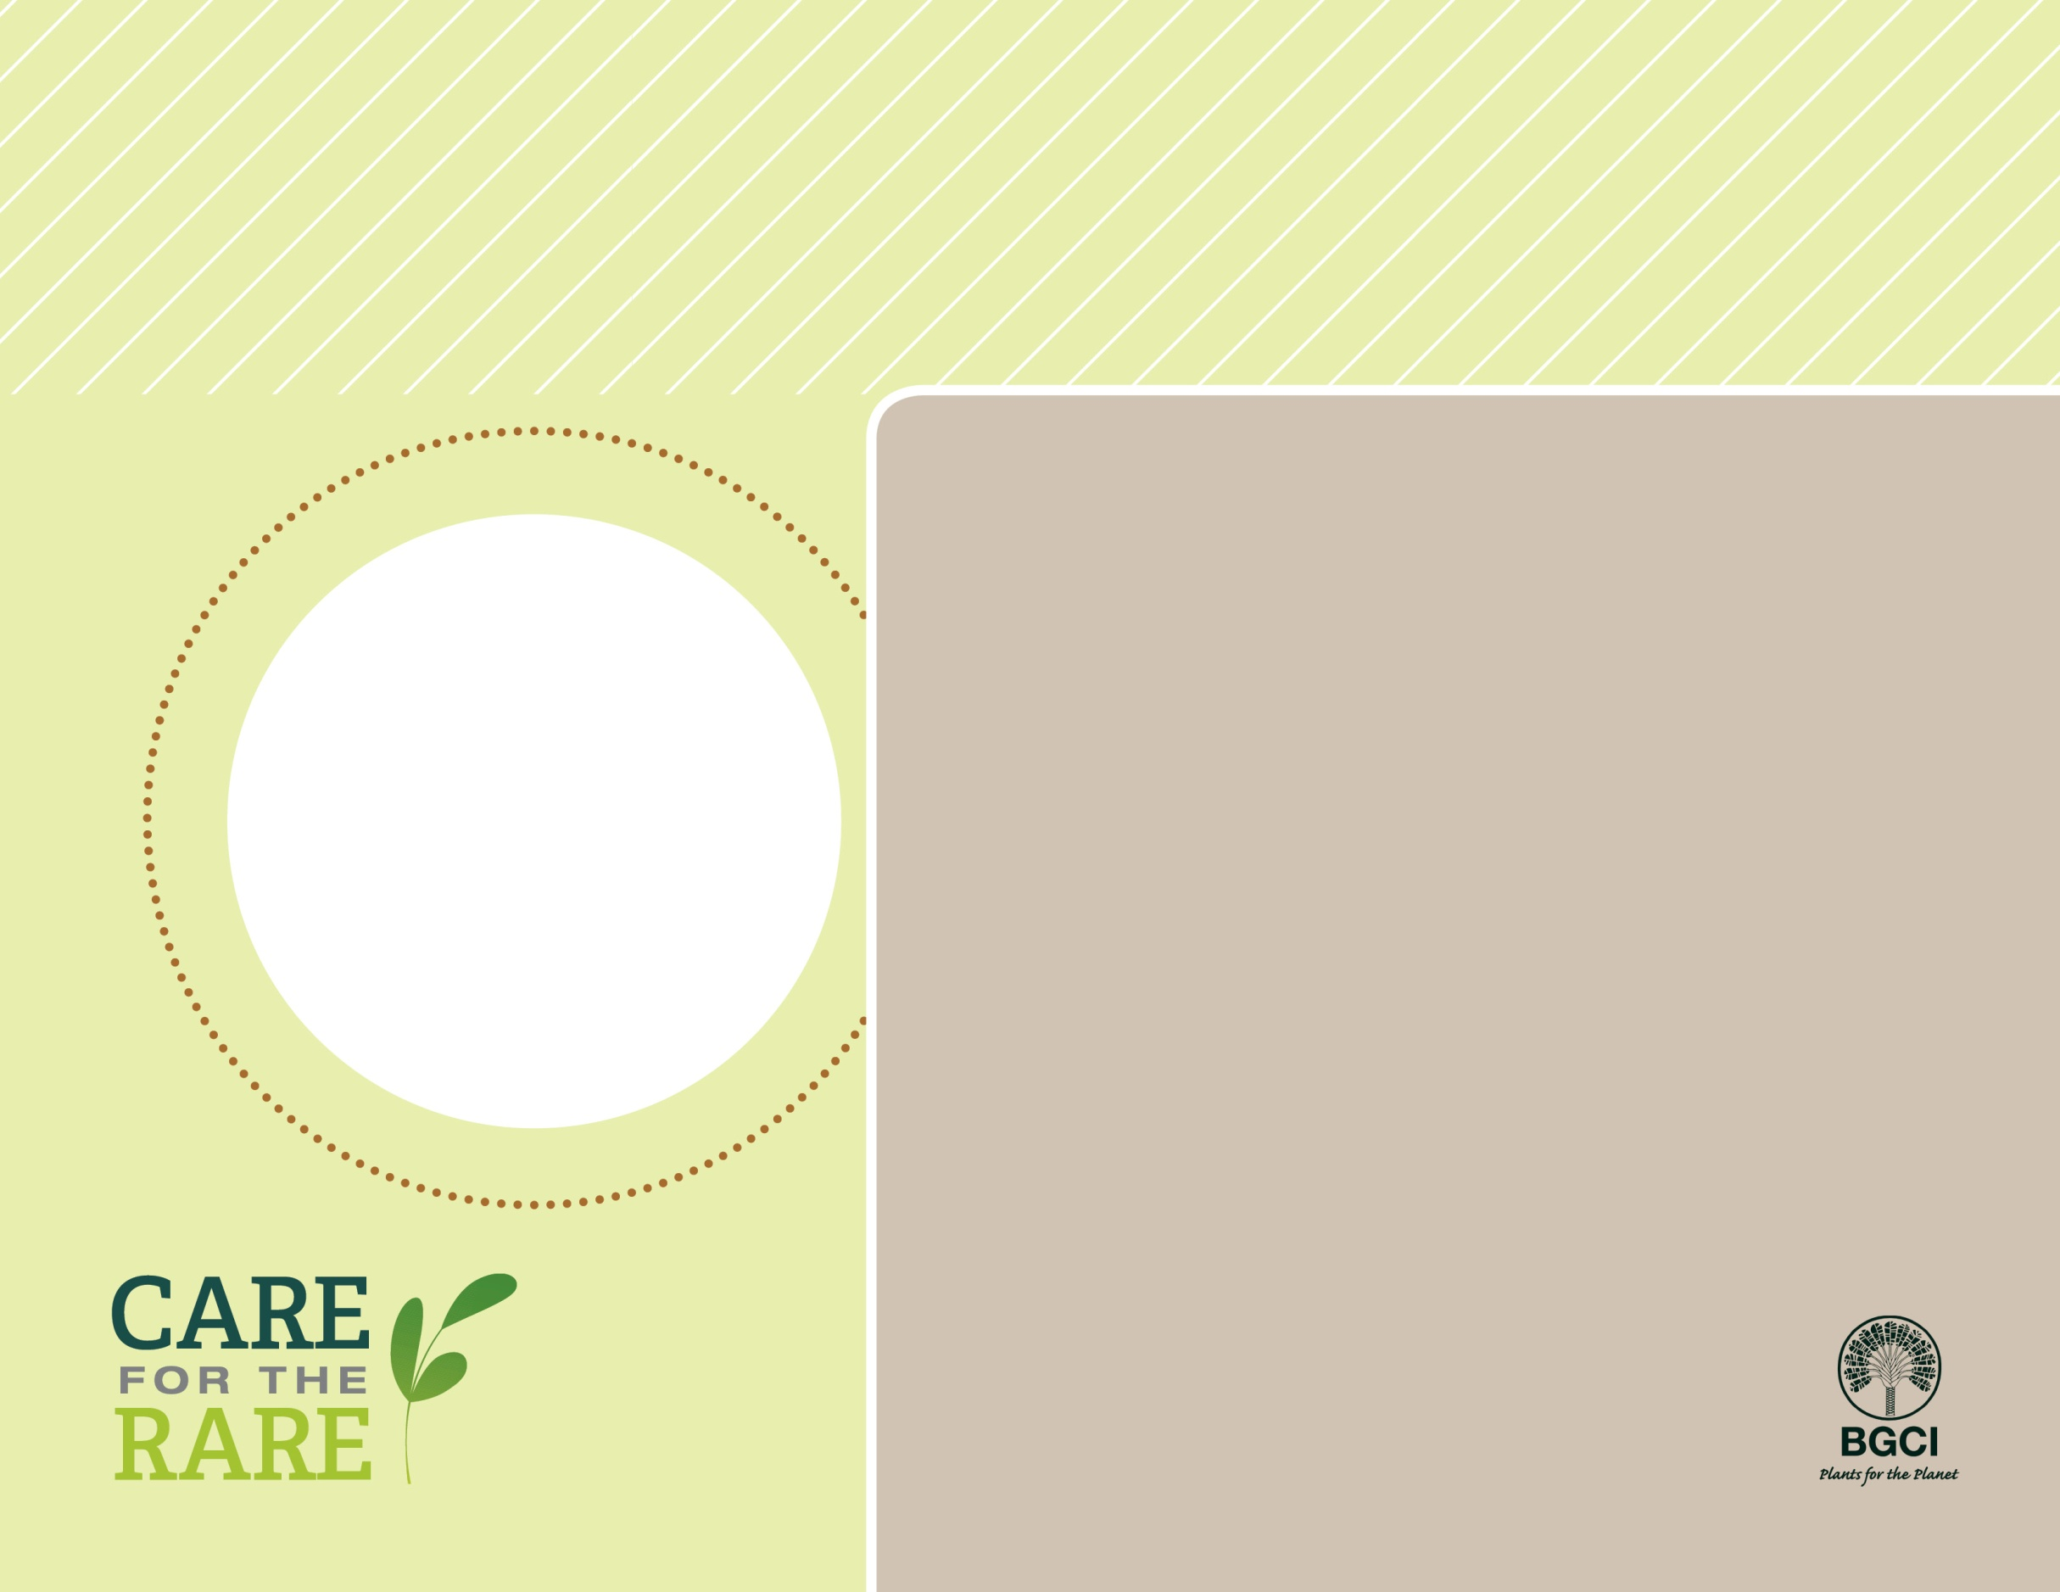

**About me:** I am a very large conifer native to Japan, but I am not a true cedar. In fact, I am closely related to the giant redwood of the U.S. I can grow to be over 200 feet tall and scientists think that one tree can survive thousands of years in the wild.

**Why I’m rare:** Due to the strength and durability of my wood, I am often used for timber and construction. Extensive logging has greatly depleted my natural populations, so any remaining trees grow far away from one another.

**My story:** My survival depends on forests planted by people, and some of my remaining populations are protected in nature preserves. Genetic diversity is a concern for any planting efforts.

**How you can help:** Buy certified responsibly-grown forest products to support sustainable forestry practices and prevent harmful logging that has damaged trees like me.

**Your**

**Logo**

**Here**

Japanese cedar

*Cryptomeria japonica*

**PHOTO BY: D. DON, JARDIN DU LUXEMBOURG**