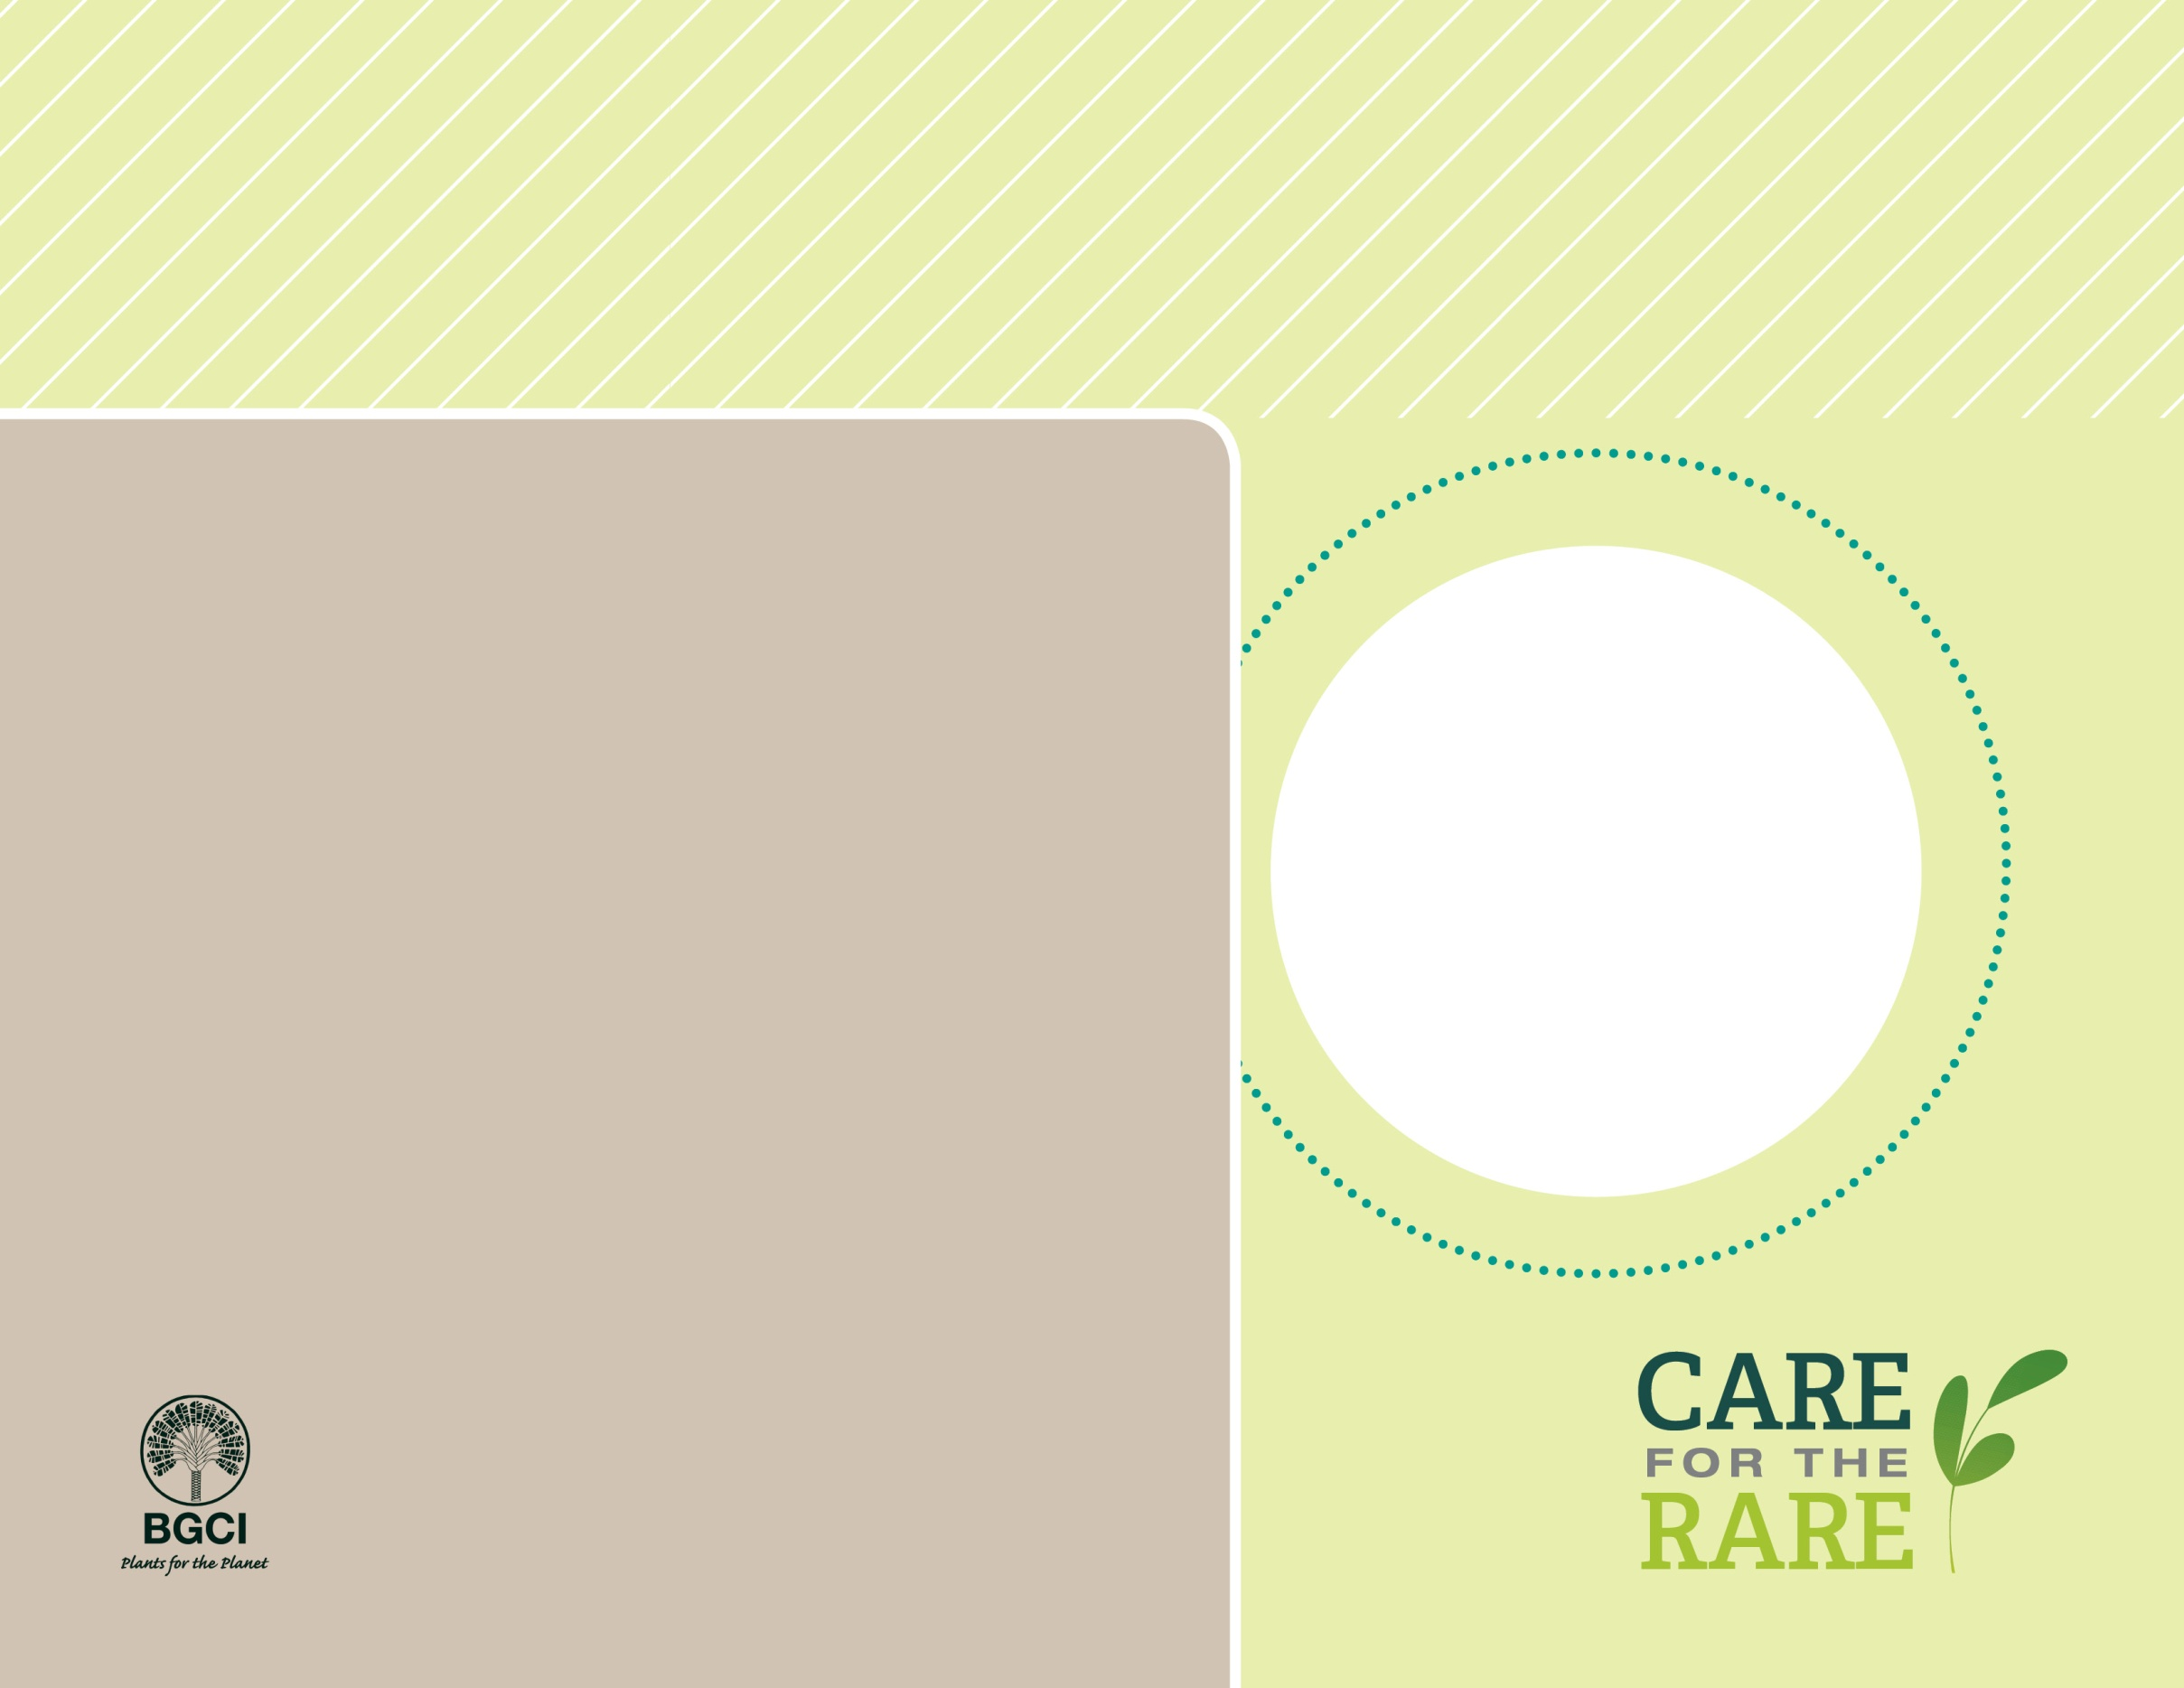

**About me:** I live only in forests on Orchid Island near the southern coast of Taiwan.

**Why I’m rare:** Orchid Island is very tiny (less than 10 miles long!), making it hard to find room to grow. Habitat destruction, including for a nuclear waste facility, is making my life pretty difficult.

**My story:** I’m related to the cinnamon tree, which means my genes may help future cinnamon crops become tastier, more resistant to disease and pests or become more productive. Chinese scientists also recently found chemicals in my leaves that have anticancer properties.

**Why you should care:** Over 25% of all prescriptions drugs available today are derived from plants.

PHOTO BY: UNITED STATES BOTANIC GARDEN

Canela*Cinnamomum kotoense*