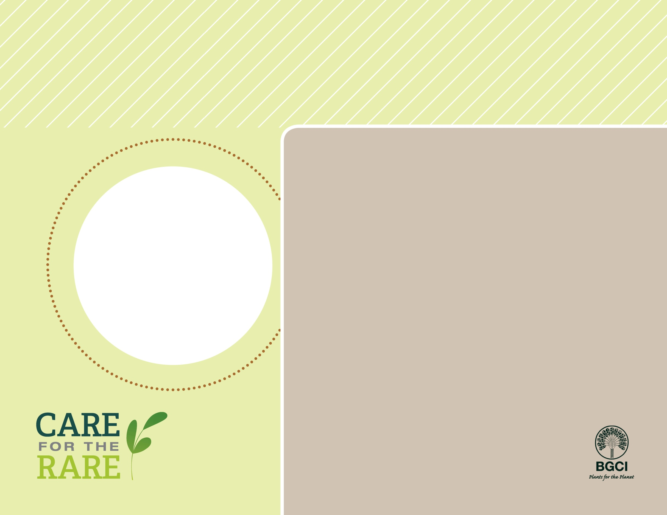

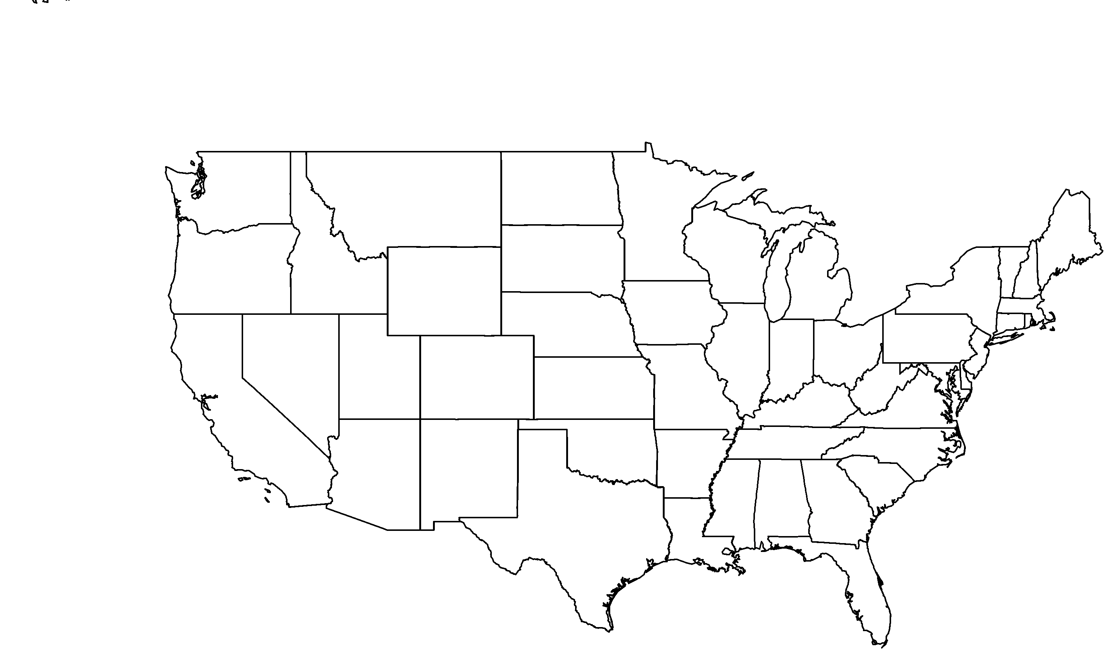

**PHOTO BY: DAVID GRABER**

**About me:** I am a beautiful Manzanita that only grows in the Pecho Hills of the central coast of California.

**Why I’m rare:** My home is shrinking in size due to land development. If my home and the ecological processes that I need to survive disappear, then I will also cease to exist.

**My story:** I belong to the same plant family as blueberries and rhododendrons. I have beautiful smooth red bark and white, u-shaped flowers that turn into small red fruits. My fruits are edible when they are young and can used to brew a yummy cider. But don’t try them when they are ripe or you may have to make an emergency trip to the dentist! Please remember: Do not pick fruit, leaves or flowers of plants in the Garden.

**How you can help:** Volunteer at botanic gardens to help restore natural areas and native plants.

**Your**

**Logo**

**Here**

Pecho manzanita*Arctostaphylos pechoensis*