

**About me:** I grow only on Otay Mountain and San Miguel Mountain in San Diego County, and nowhere else in the world!

**Why I’m rare:** I have probably always been rare. I live in these areas because they have an unusual soil type that I can deal with better than other plants.

**My story:** I am one of the few manzanitas with upright dormant flower clusters. I only come back from seeds after fires burn through my chaparral home. My common name manzanita comes from the Spanish word meaning ‘little apple’ because my fruits look like little apples (although I am not related to apples).

**How you can help:** Support organizations that conserve and preserve native flora by donating, becoming a member, or volunteering.

Otay manzanita

*Arctostaphylos otayensis*

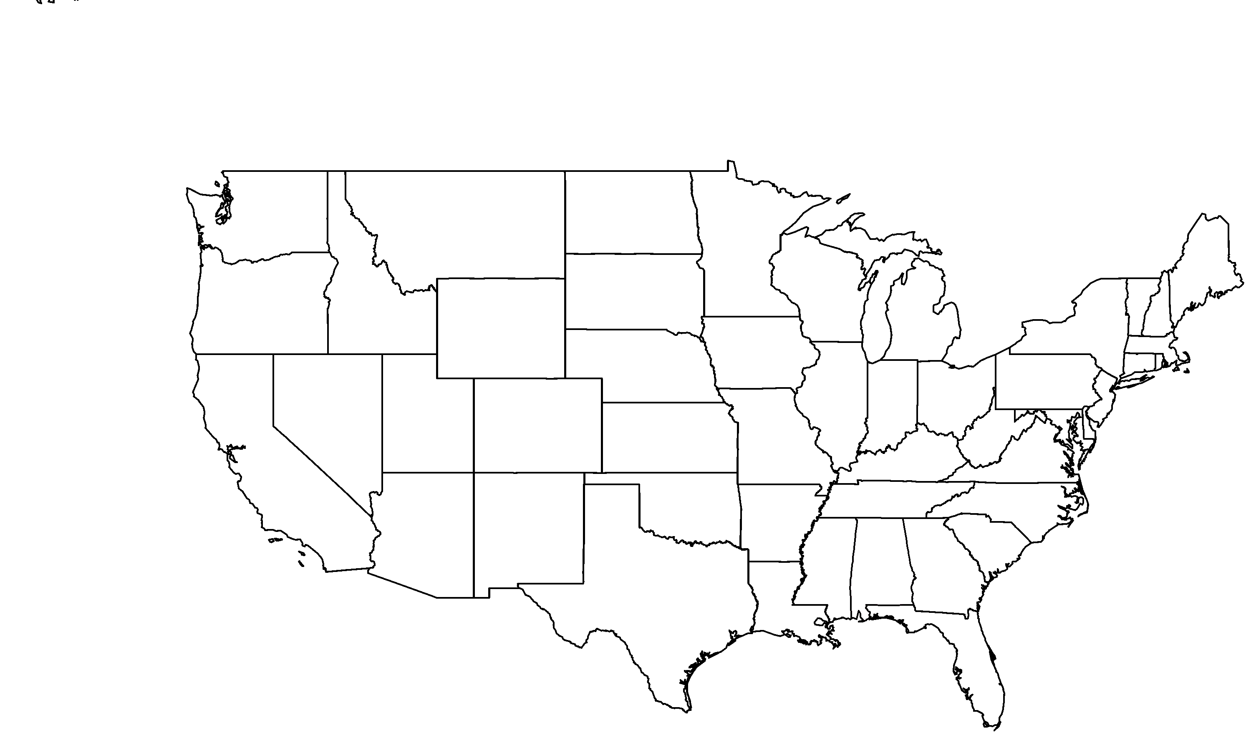

**PHOTO BY: RANCHO SANTA ANA BOTANIC GARDEN**

**Your**

**Logo**

**Here**