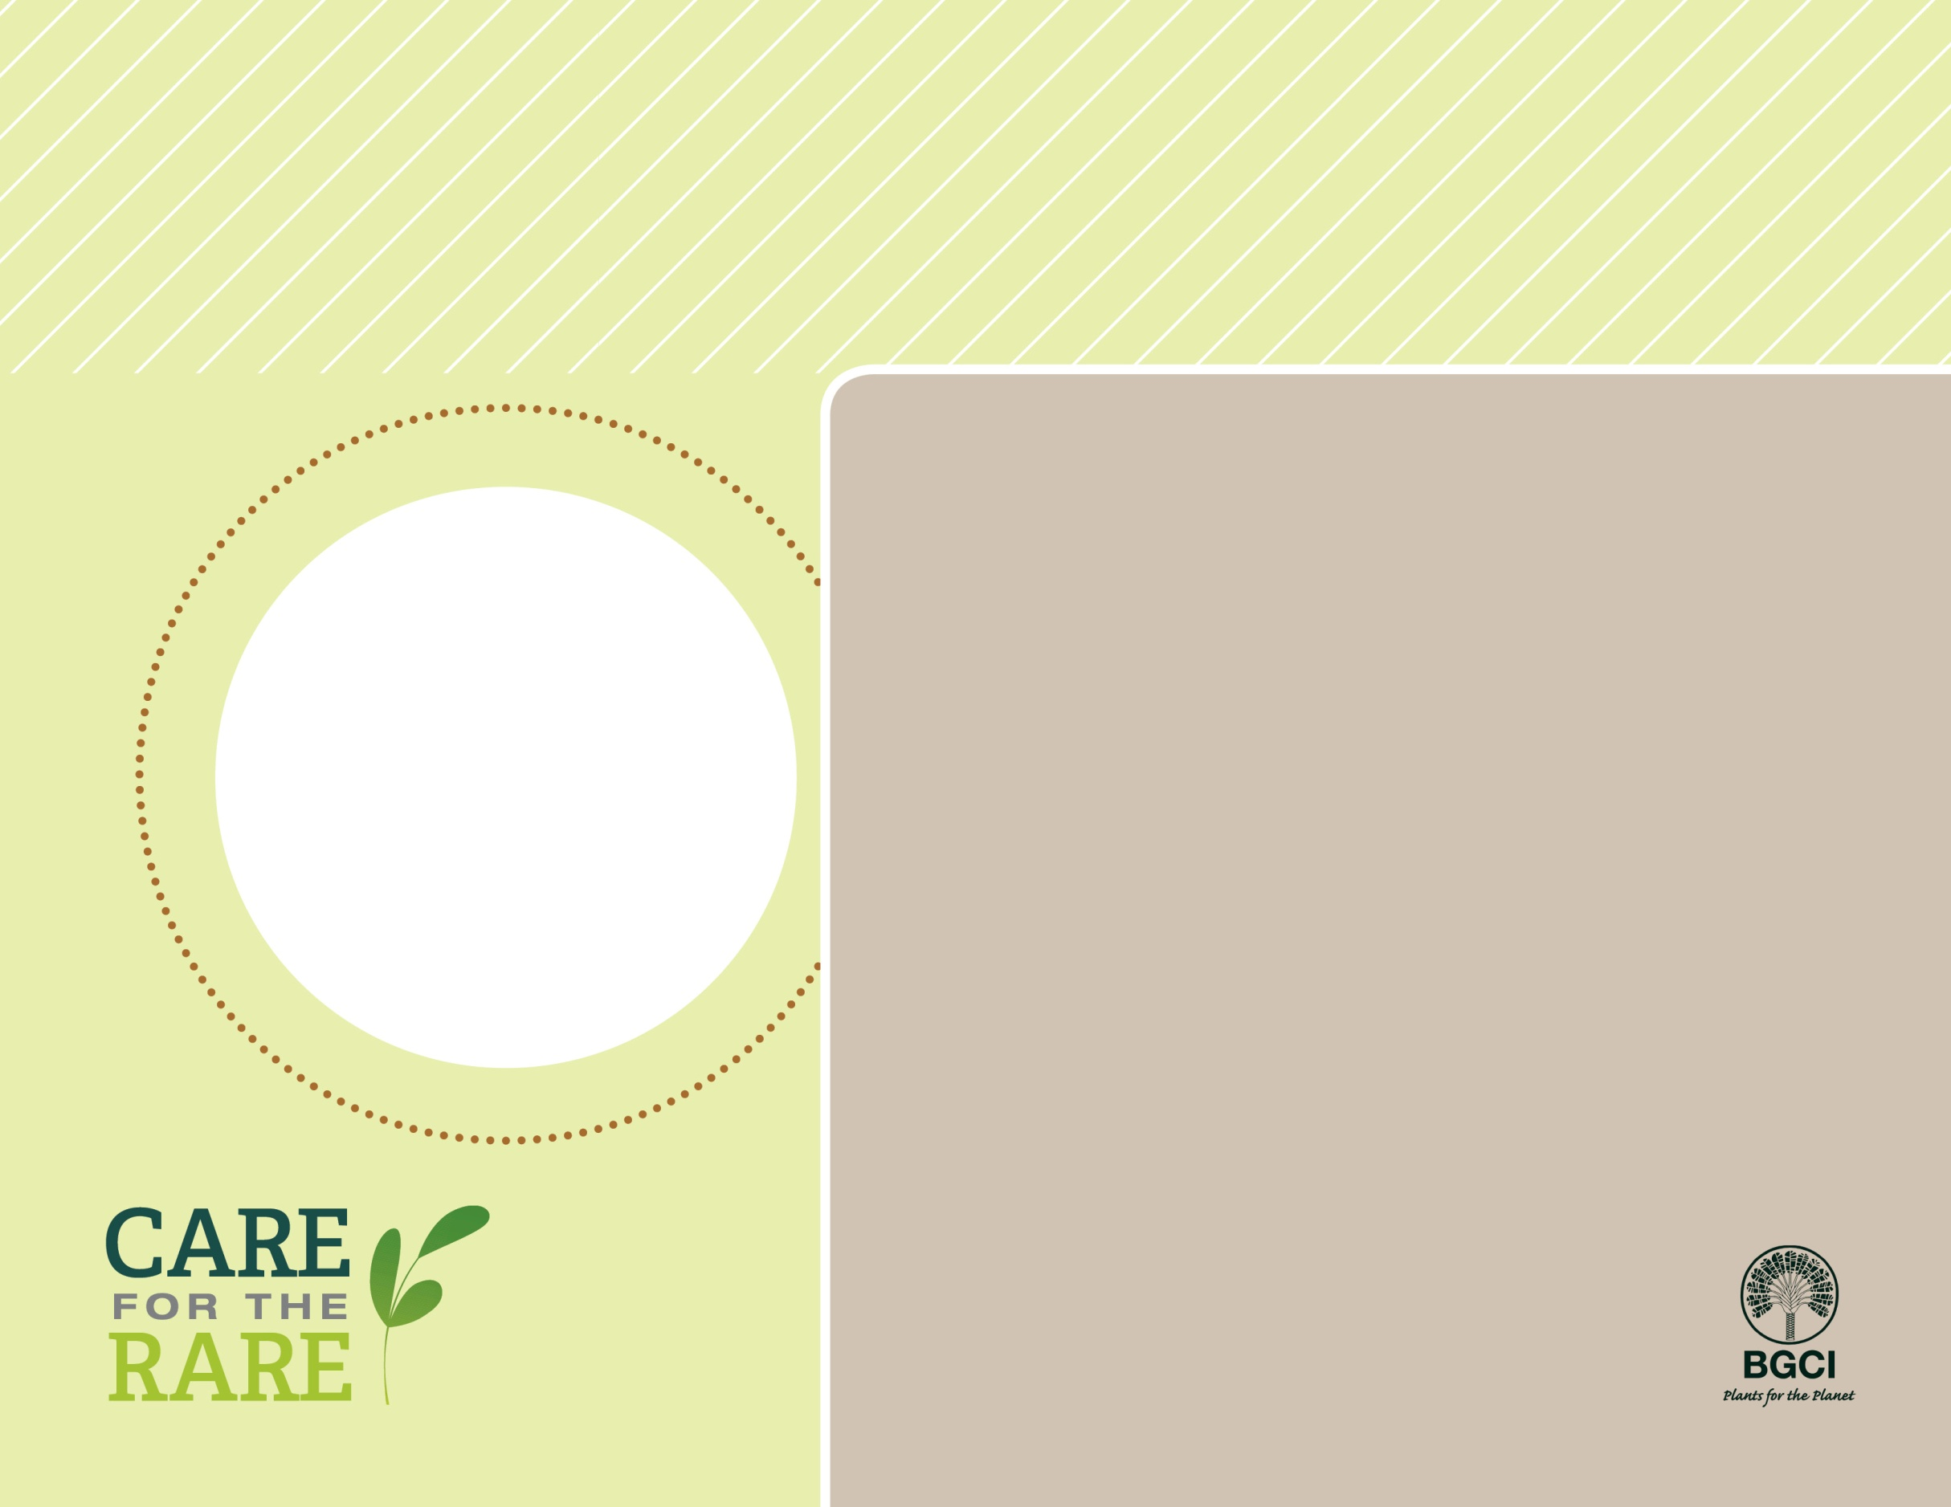

**About me:** I love the San Gabriel Mountains and don’t grow anywhere else. I am long-lived in the wild.

**Why I’m rare:** Although I have probably always been rare, my home is currently being threatened by power line construction.

**My story:** For many years, I dumbfounded botanists and they considered me a hybrid. More recently they have recognized me a distinct subspecies. I am related to blueberries, but not as tasty!

**How you can help:** Protect natural areas and plants like me by staying on designated trails when hiking.

San Gabriel manzanita

*Arctostaphylos glandulosa* var. *gabrielensis*

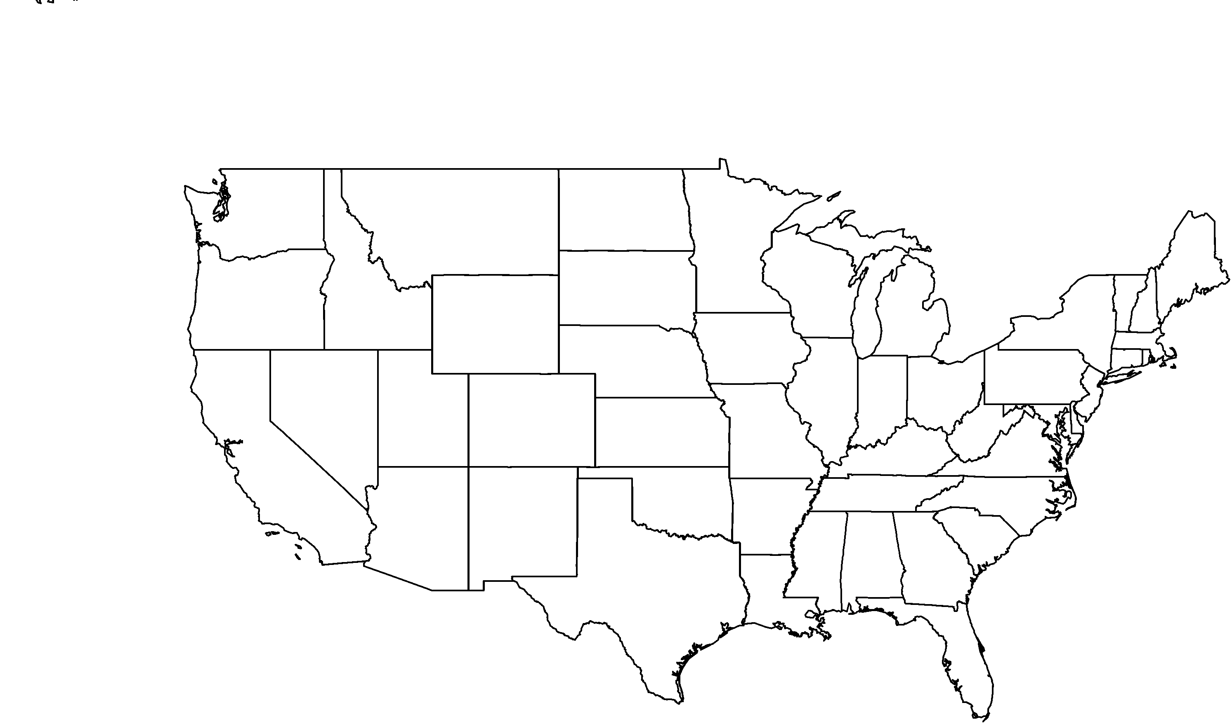

**PHOTO BY: RANCHO SANTA ANA BOTANIC GARDEN**

**Your**

**Logo**

**Here**