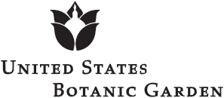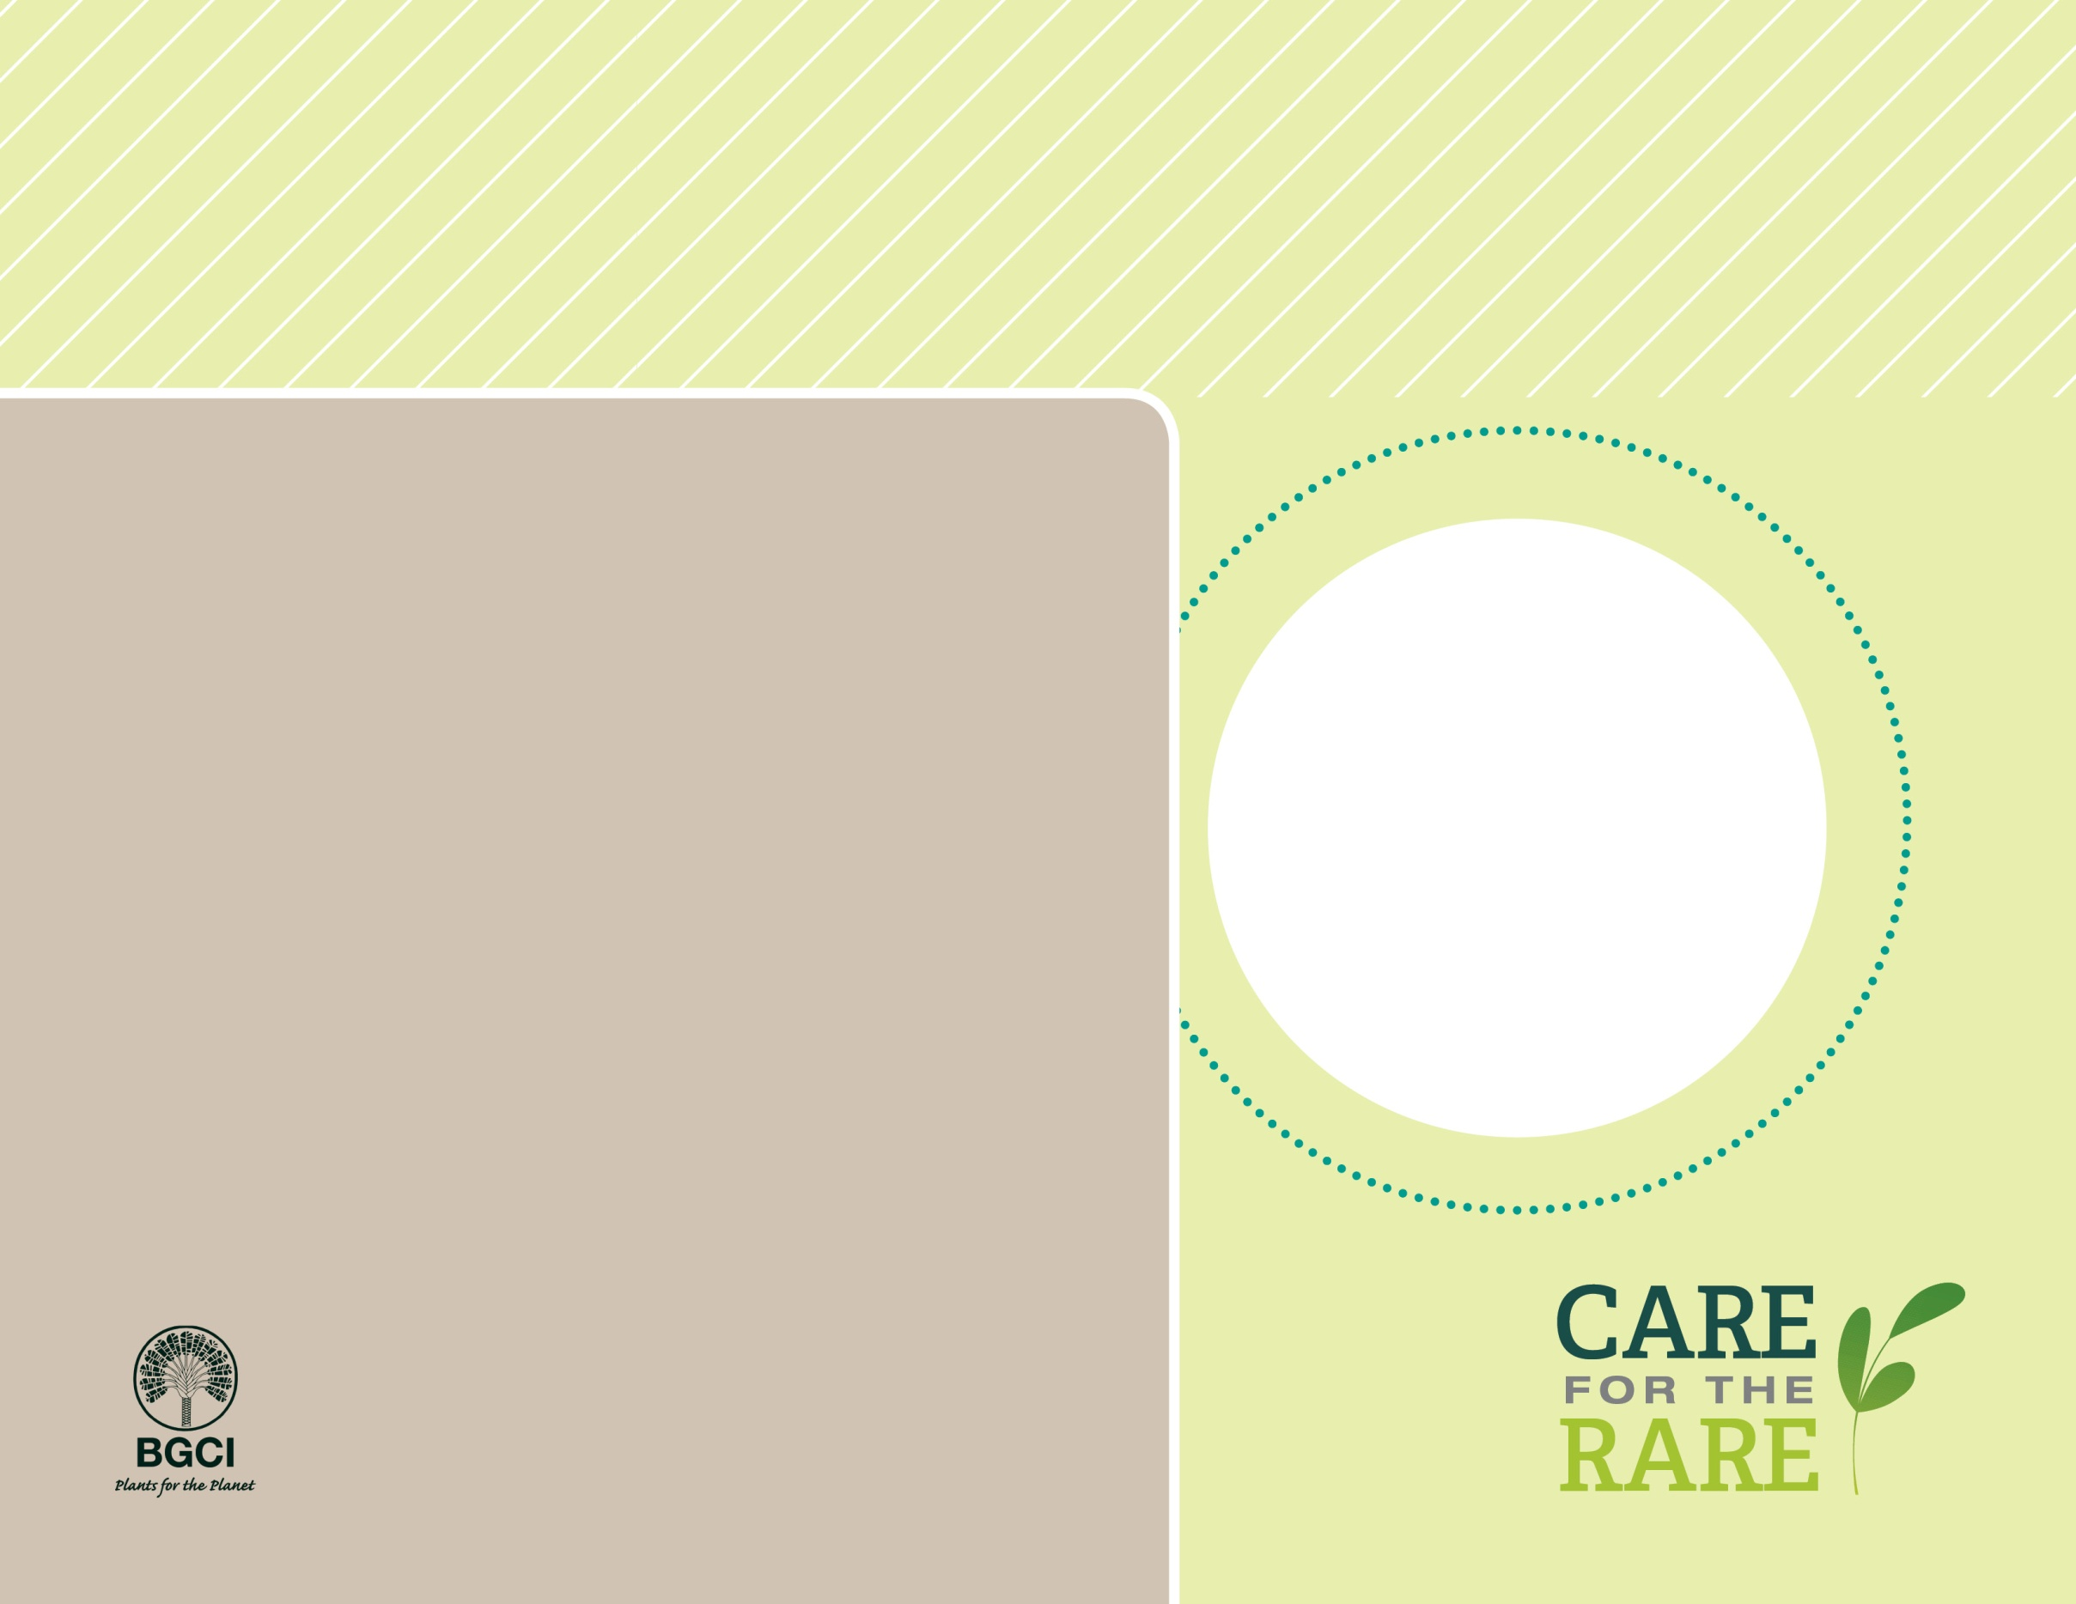

**About me:** I am an endangered plant found only in the tiny country of Lesotho (located in the middle of South Africa). Look at my leaves and you’ll see why I’m called Spiral Aloe.

**Why I’m rare:** My pollinator, the Malachite Sunbird, is becoming rare, making it difficult for me to produce seeds. I’m also unsustainably harvested from my habitat for medicine and to be sold to plant collectors.

**My story:** I grow in rock crevices at high elevations in the Maluti Mountains. I’m proud to be the only Aloe that grows in cold alpine habitat!

**How you can help:** Support the cooperative efforts between botanic gardens, conservation programs and nurseries to propagate plants like me for commercial trade to help reduce collections from wild populations.

Spiral Aloe

*Aloe polyphylla*

PHOTO BY: STAN SHEBS